# Topic 1: C Programming Language

## The First C Program

### Guidance

* Chapter: C-Primer-Plus.pdf Chapter 1-2
* Spend time: 1 day
* Learn suggestion: Write canonical C code
* Key points:
  + Why do we need C Programming Language? What can it be used for? What are the advantages and disadvantages?
  + How many C language standards are in C?
  + How to make the binary file for different standards in gcc? What other options can be used in gcc?

### Practice

1. How to add a comment for a function?

The single-line comment isn't recommended because some compilers do not support it.

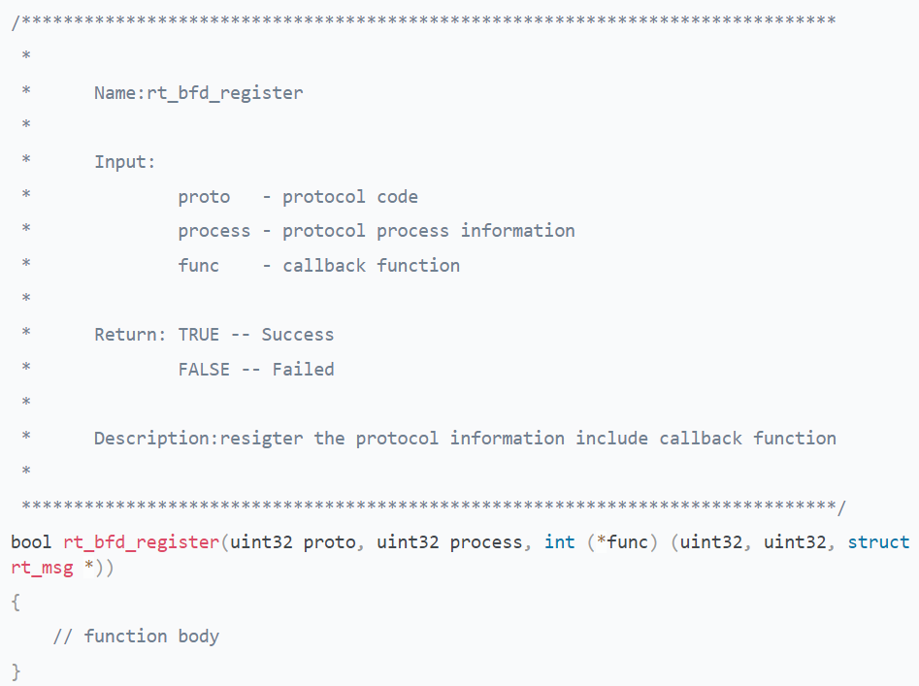

1. What should we pay attention to when declaring a variable?

* The variable name consists of letters, digits, and underscores, starting with a letter or an underscore. Commonly, a variable starting with a letter is used for regular users, and beginning with an underscore is used for system base functions.

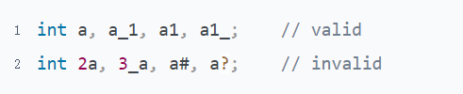

You can find here that there are really many functions whose names start with an underscore

<https://github.com/torvalds/linux/blob/master/include/linux/socket.h>

* There are 32 reserved words in the C programming language; the variable name defined cannot be the same as the reserved word.



* Variable names are case-sensitive.



* Variable names should be as meaningful as possible, Which can improve code readability

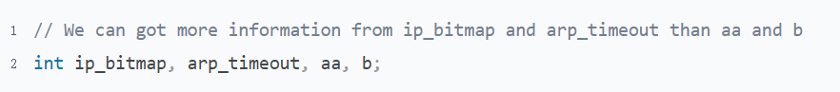

1. Can a C program exist without the main function? How is this possible? Why?

There are 3 concepts

User-level, all functions written by the general programmer in the program

System-level, file system, elf in Linux

libc-level, the function between the user and the file system, in order to help users using C, such as libc_start_main

* main() is the default function name of user-level
  + Step 1, there is a program named test.c, get an executable file a.out by command "gcc test.c"

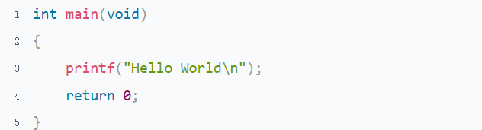

* + Step 2, get the Entry point address by command "readelf -h a.out | grep Entry"



* + Step 3, find address 0x8048310 from the output of the command "objdump -d a.out"

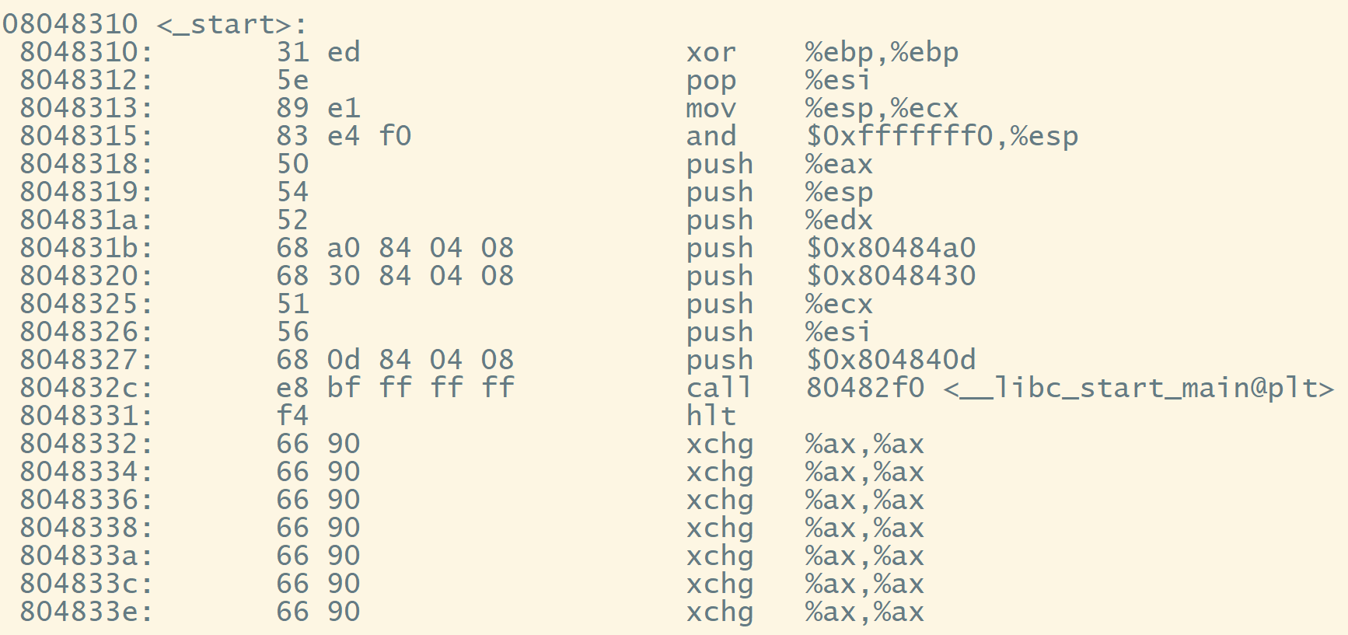

* + Step 4, what is the relationship between start_main and main

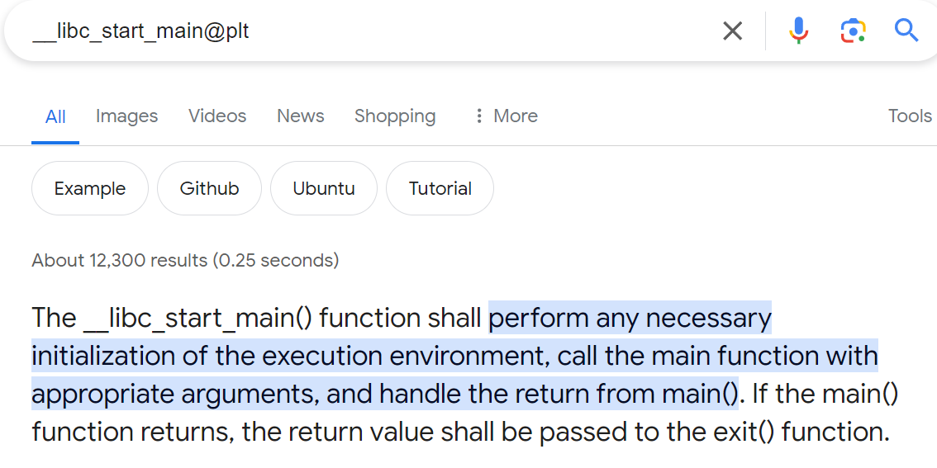

* How to change the default entry of user-level

As you can see from these four steps, the main is just the default function entry at the user level, which is called by libc_start_main. Because the libc_start_main call to main is fixed and cannot be modified, you cannot use libc_start_main if you want to achieve your purpose.

* + Step 1, option -nostartfiles can be used



* + Step 2, change test.c to blew

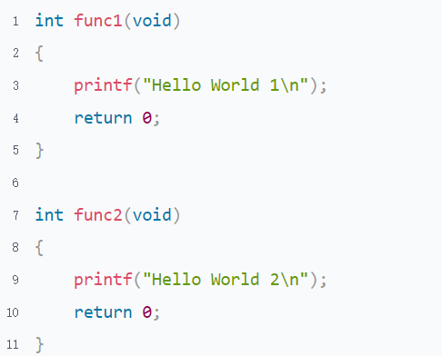

* + Step 3, get a new executable file a.out and run it by command "gcc test.c -nostartfiles -efunc2 && ./a.out"



* Why is there a segmentation here occurrence

exit() will be called in libc_start_main to perform some clearing actions When main() returns normally. However, the link to the startup file of libc is closed, libc_start_main is not enabled, and no clearing action is performed, resulting in an exception. So, the issue can be fixed by changing the return to exit.

1. How does a C source code become an executable file, Fill in the table below

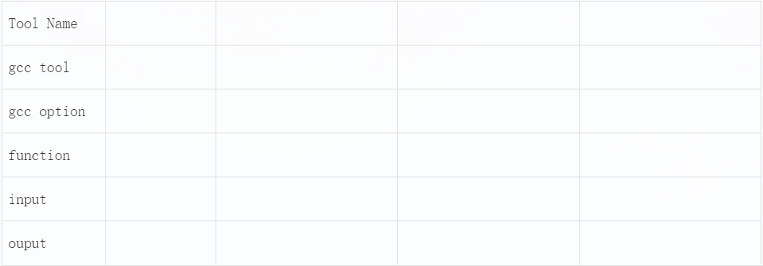

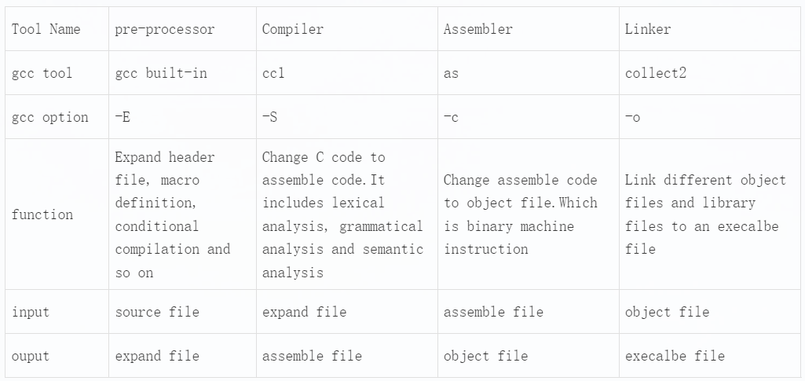

## Functions

### Guidance

**Functions**

Guidance

* Chapter: Pointers-On-C.pdf 7.1-7.3; The-C-Programming-Language-2nd.pdf 4.1-4.2
* Spend time: 1 day
* Learn suggestion: Compare with different types of functions
* Key points:
  + Can variables defined in one function be accessed in another function?
  + What will happen if you define a function with the static keyword?
  + Write a simple program and read the assembly language

### Practice

1. Why do we need functions? How to define a function? What does a function consist of? What are the naming rules for function names?
   1. The reason for using functions are

* Structurized, Separate a big logic into smaller logic. Make your code more organized
* Uncoupled， Each function is independent of the other， Enhancing the code maintainability
* Reused， It can be called multiple times in different places
  1. The syntax of a function definition is

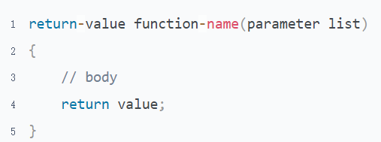

* 1. The syntax of function declaration is

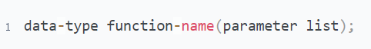

* 1. The naming rule of the function is totally the same as a variable name

1. Why do we need function declaration? If there is no function declaration, sometimes the compiler will report an error, sometimes report a warning, sometimes not any error or warning. Why is this? Illustration separately
   1. Why do we need function declaration?

This is a historical legacy issue because the C language was born 40 years ago, When CPU and memory resources were very limited. If there were no function declarations, the compiler would need to read the code multiple times to find the definition of the called function, consuming unnecessary CPU and memory resources.

Now that hardware resources are sufficient, why do we still need function declarations?

* With function declarations, the compiler only needs to read the code once, which can also improve compilation speed.
* Due to function declarations are short and usually concentrated at the beginning of header files or source files, they can help readers quickly understand the function. This improves the program's readability and maintainability.
* Improve program compatibility and increase code consistency. Because the code written now needs to be consistent with old code and needs to be used on compilers with different capabilities.
  1. The compiler creates an implicit declaration for a function when the compiler finds it is undefined. The data type of implicit function declaration is int.

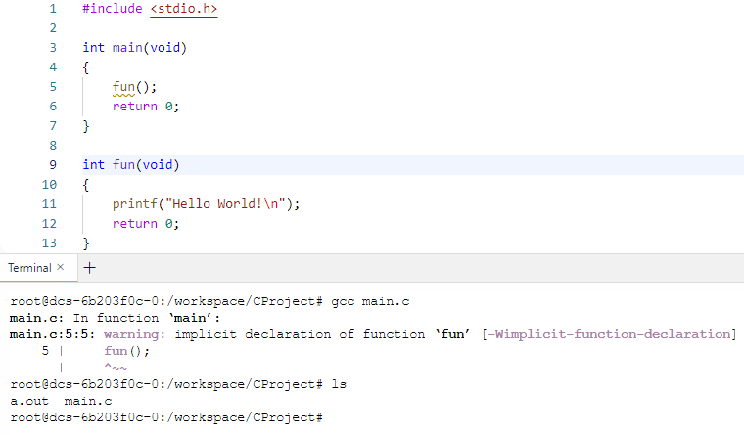

* 1. If the actual return type of the function is not, an error will occur

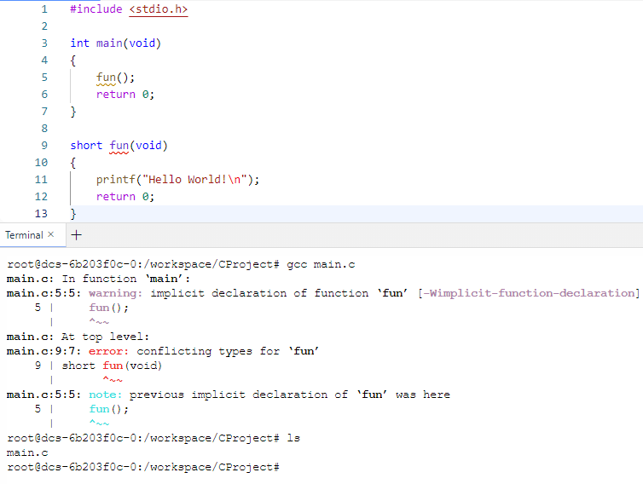

* 1. The compiler can work well when it has already found the definition of the be called function

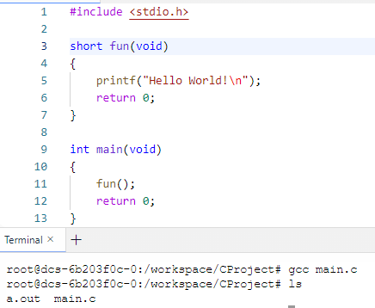

1. What are the matters that need attention for function return values?

* The return value must match with return type

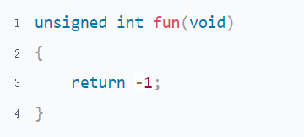

* Never return an address that is stored on a stack

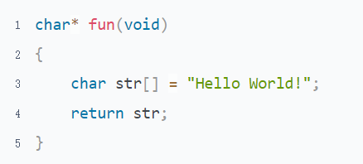

* The return value is the right value, It can not do operator operations

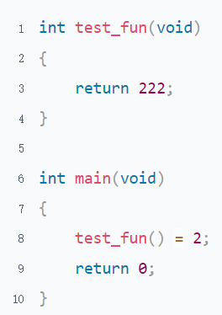

1. What is an inline function? What is the form of it?

A function declared by the keyword inline is an inline function. It will be expanded in the calling function in the compile stage. Which can save calling overhead

There are 2 forms of inline function

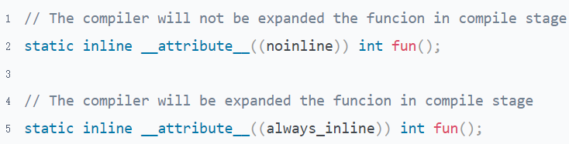

1. What is the difference between inline function, normal function, and macro function? What are their advantages and disadvantages?

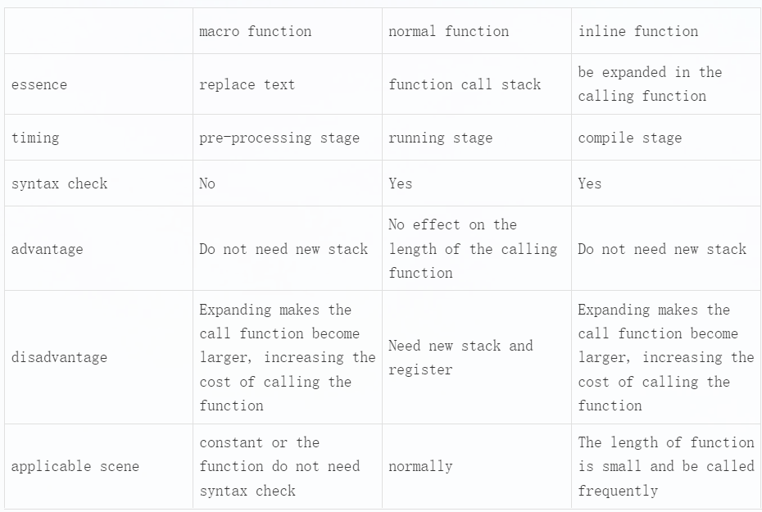

## Function Call Stack

### Guidance

* Chapter: Computer-Systems-A-Programmers-Perspective.pdf 3.4 3.7.1-3.7.4
* Spend time: 2 days
* Learn suggestion: Read the assembly language
* Key points:
  + When are local variables allocated space and when are they released space?
  + Why the value of the function argument did not change when we changed the value of formal parameters
  + How many ways can a computer store stack data? Which approach does Linux take?
* Reference Code

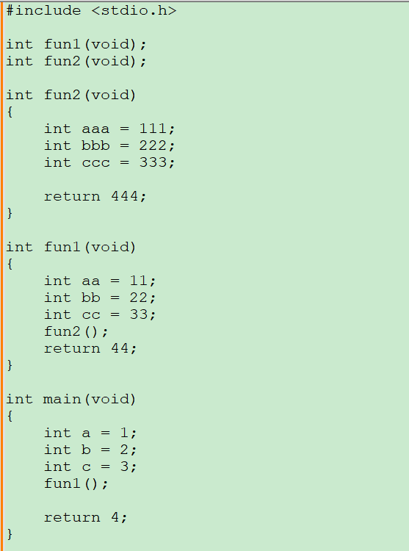

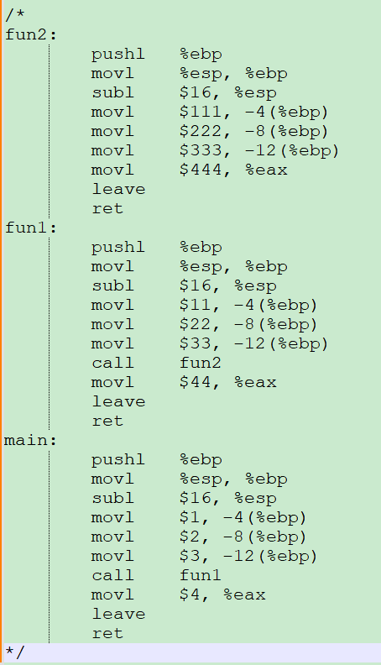

### Practice

Suppose, The initial address of %ebp is 0x1100, %esp 0x1000 when the main function is called. The program runs on a computer with a decrement stack

1. Draw an image for the virtual address space of the Linux process in 4G memory

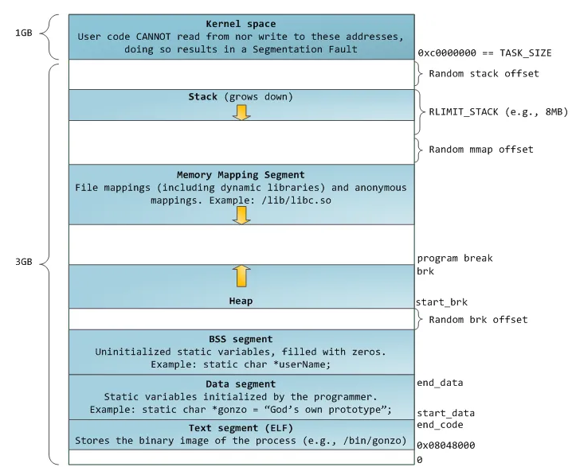

The top most region of the address space is reserved for code and data in the operating system that is common to all processes

The lower region of the address space holds the code and data defined by the user’s process.

1. What is the difference between a, b and c? From the stack perspective

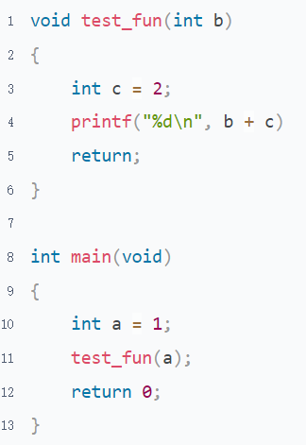

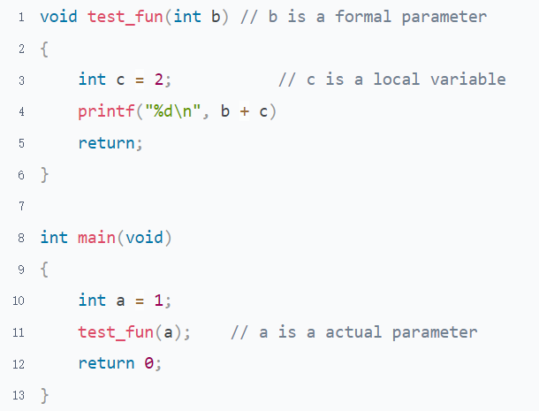

The stack does not create any space for the formal parameter. It just a representation of function argument in C language level

The actual parameter is stored on the stack of the function who do call， and the variable in the function is stored on the stack of the function being called.

For more detail, refer to the program "Function call stack.c"

1. The practice is based on the program "Function call stack.c"
   1. Write the corresponding C code next to the assembly statement

return address, is the following instruction address of the called function. It'll be stored in the PC register when the called function is returned.

Refer to the program "Function call stack.c"

* 1. Draw some pictures or tables to illustrate the memory layout and content of the register after each assembly instruction.

Refer to "Function call stack.xlsx"

# Topic 2: Basic Concept

## Constant & Variable

### Guidance

* Chapter: C-Primer-Plus.pdf chapter 3; Pointers-On-C.pdf chapter 3
* Spend time: 1 day
* Learn suggestion: The Linux tools objdump and readelf can be used to help you know more about how a variable is stored in memory.
* Key points
  + Where are the different types of variables stored in virtual memory?
  + What keywords can be used to declare a variable? What are the differences between them?
  + What kinds of constants are there in C?

### Practice

1. How is C represent and store characters? What are the special characters? Write a program to describe the relationship between ASCII and characters.

In C, characters are printed with %c and numbers are printed with %d. Here we can take a look at the difference between characters and numbers by printing in.

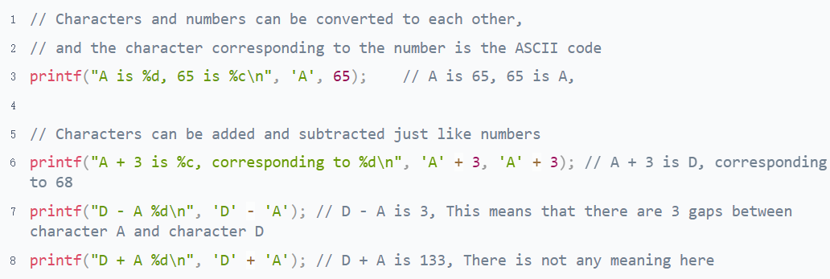

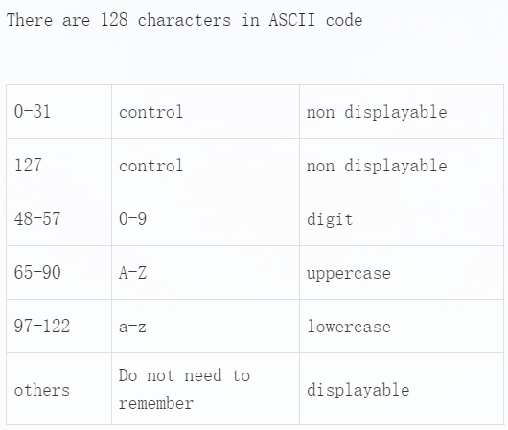

Special Characters

Broad definition：All characters except numeric uppercase and lowercase are special characters

Narrow definition：Control character(0-31,127) + escape character(some of here is also control character)

1. How to define and represent different bases in C? Write code to illustrate

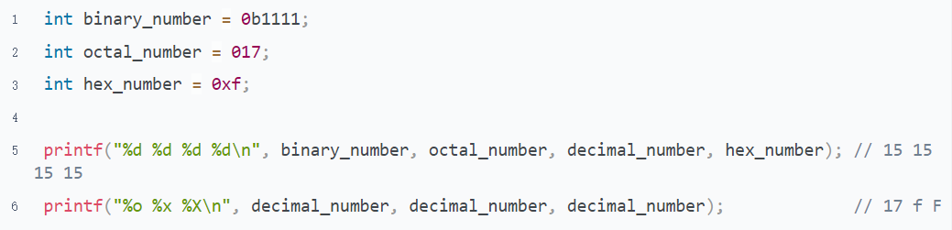

1. How to define and use enumeration? Write a piece of code to describe

* Enumeration can help the coder better understand code and enhance the readability of code

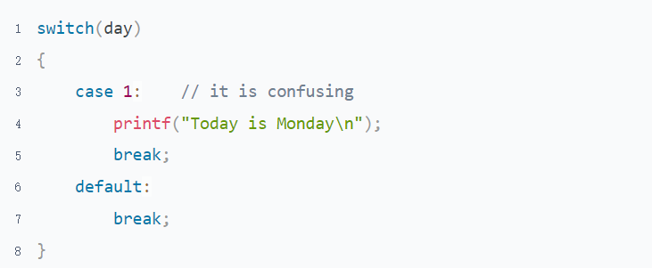

* The usage is very flexible

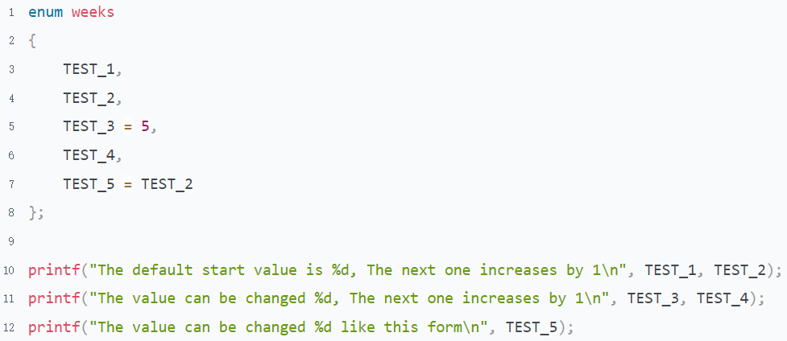

* It can also be combined with the typedef to define a new alias, Improve code readability

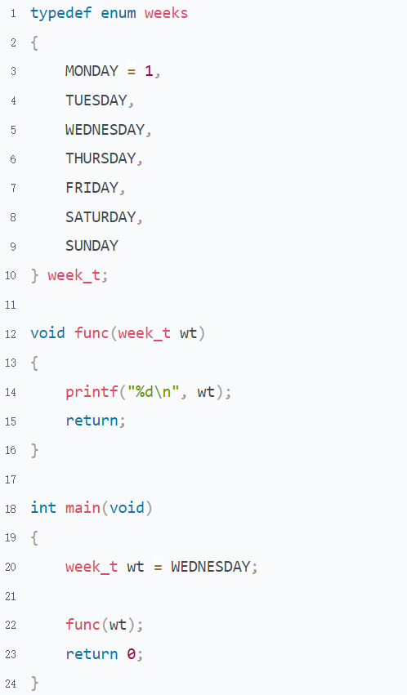

1. Why do we sometimes say that string is constant？ Illustration

* Compare the output of a and b with objdump -h to see which part is 5 bytes larger

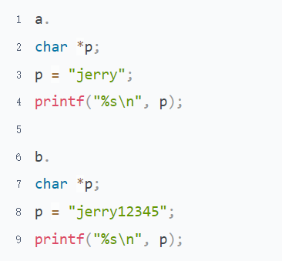

* To check the address. Refer to the program "The address of constant and variable.c"

1. Is it possible to change the value of a const variable? How to do?

It's different for global and local variables.

global variables are declared by const are stored in .rodata, they cannot be modified anyway.

The corresponding local variable is stored on the stack and can be modified by the pointer.

1. Why do we need keyword static to declare a variable?

When it is used as a global variable, the scope of the variable changes to the file that defines it, that means, the variable cannot be used in a source file other than the current file.

It will be stored in the global variable table when it is used as a local variable

. The variable’s lifetime does not depend on the call stack.

1. Where are the following variables stored in the memory layout? Provide the evidence

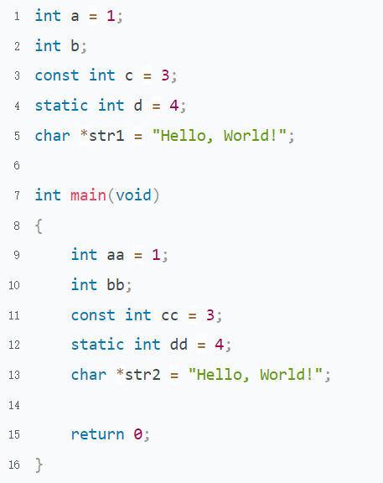

The address of stack and heap can be checked by command "cat /proc//maps"

Refer to the program "The address of constant and variable.c"

## Operators & Expressions

### Guidance

* Chapter: Pointers-On-C.pdf chapter 5
* Spend time: 1 day
* Learn suggestion: Thinking like a computer rather than a human.
* Key points
  + What is the relationship between expressions and statements?
  + What is the meaning of the operator's side effect?
  + When does short-circuit occur in expressions?
  + How a complex expression is executed?
  + Memorizing the priority of some operators is necessary.

### Practice

1. What are the rules of expression operation?

You can understand it in your own way and don't need to memorize all of it. In particular, the operator precedence can be resolved with parentheses if you're unsure about it while programming. This enhances the code's readability; however, it may be necessary to memorize some common operators, otherwise, if there are a lot of brackets may impact the code's conciseness

I'd like to show you an example that I wrote here. It's not mandatory to follow.

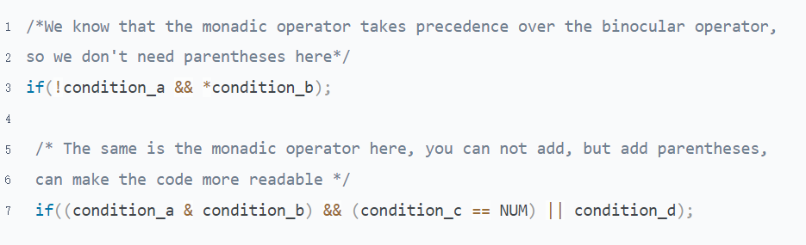

1. Pointers-On-C.pdf 5.8 question 5

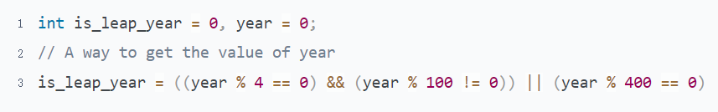

1. Pointers-On-C.pdf 5.8 question 6

Side Effect: There are some operators change the behavior of operands, and we call this change a side effect

The operators who have side effect: increment/decrement operator, assignment and compound assignment operator

Attention：Increment/Decrement operator is not recommended to use unless there is only one statement in the expression. Refer to next question.

1. What are the outputs of the following program? Try in different compilers

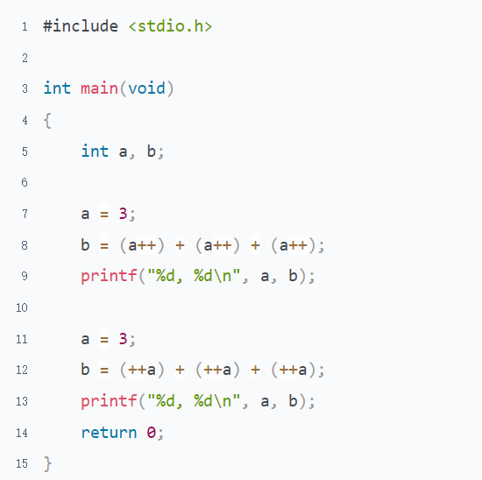

This the result of these 3 compilers. I want you know here is the result of experssions including the side effect operator is very depend of the compiler.

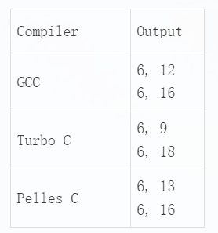

1. Pointers-On-C.pdf 5.8 question 7

Computers can't think as flexibly as humans and need to follow operators' rules. Both the 2 operators have the same priority and are executed from left to right.



1. Please explain the output of the following program

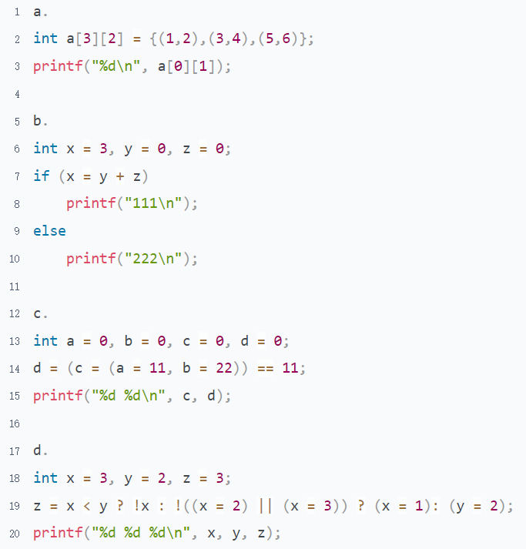

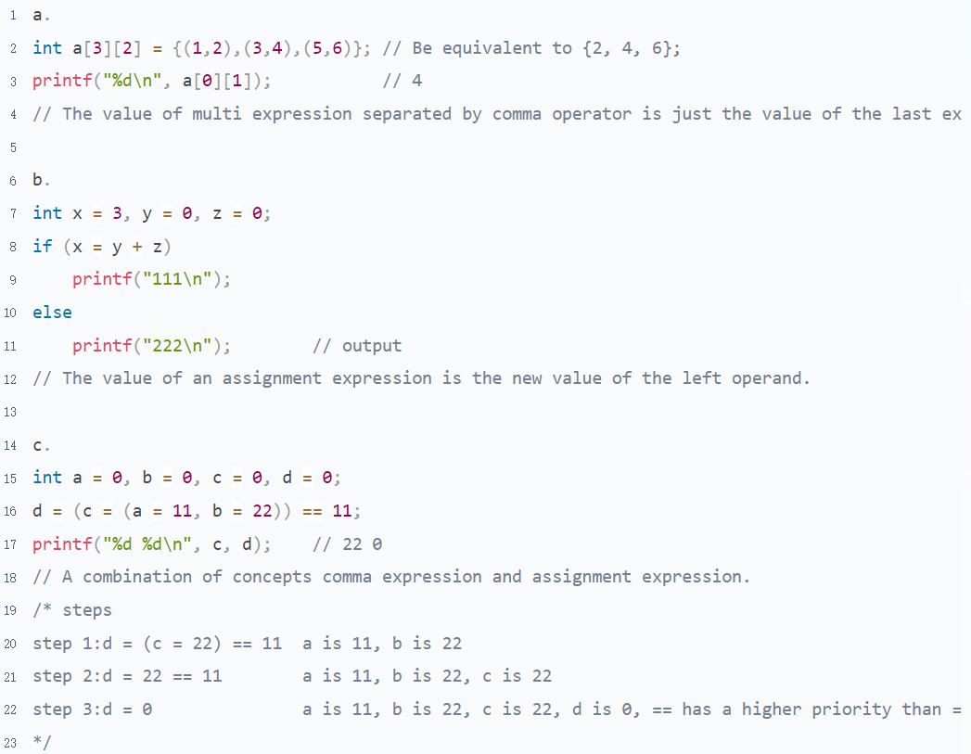

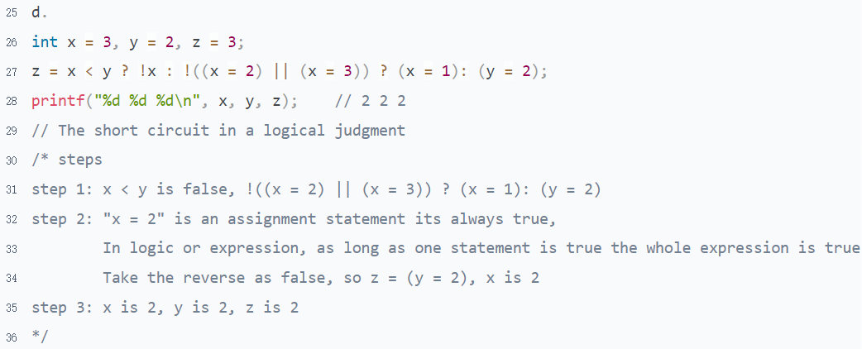

## The Preprocessor & Typedef

### Guidance

* Chapter: Pointers-On-C.pdf chapter 14; C-Primer-Plus.pdf p653 typedef: A Quick Look; The-C-Programming-Language-2nd.pdf chapter 6.7
* Spend time: 1 day
* Learn suggestion: Thinking from the perspective of the compiler
* Key points
  + What is the difference between macro definition and typedef?
  + What is the difference between macro definition functions and general functions?
  + Is the typedef used to create a new type?
  + How do we use conditional compilation to improve code portability?
  + Which steps do the macro definition and typedef work on in the compiling process?

### Practice

1. How to define a macro function? What are the points that need to pay attention?



* Do not forget to put every expression enclosed in parenthesis

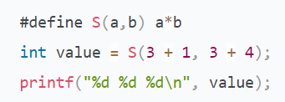

* Avoid to use the operator that may cause side effect

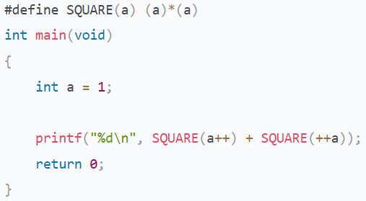

* The character "\" and do/while can be used for multi-line macros function

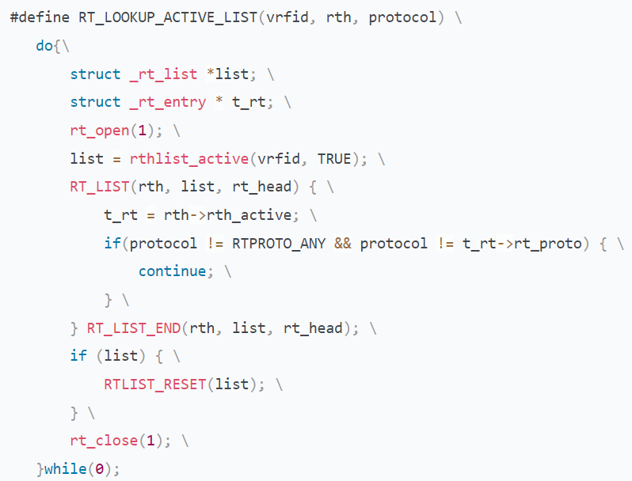

* Do not end with semicolon, it's not a statement
* Macro definition don't do any syntax check

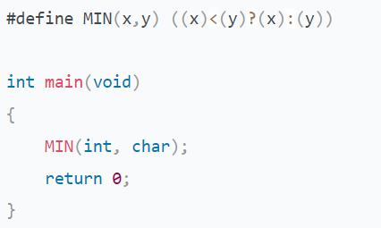

1. Write a macro MIN that accepts 3 parameters and returns the smallest one

There are 3 kinds of method

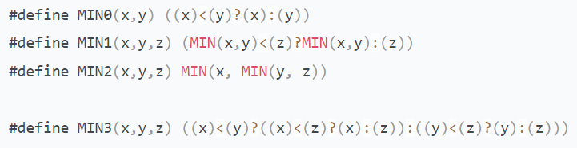

1. There is a debug function that has no output when the macro DEBUG is not defined. When the macro DEBUG is defined, debug outputs the file name, function name, line number, and content. The call and output are given.

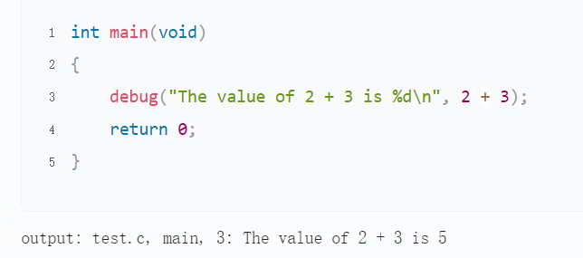

* 1. Please write the macro definition

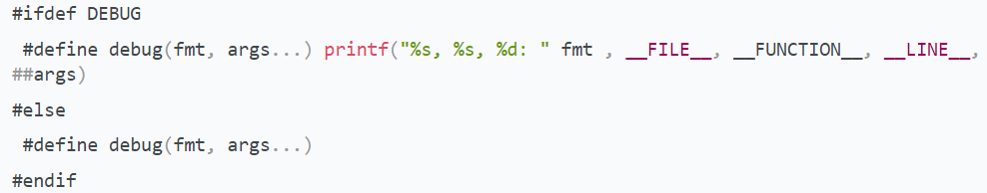

* 1. How to open the macro by command line?

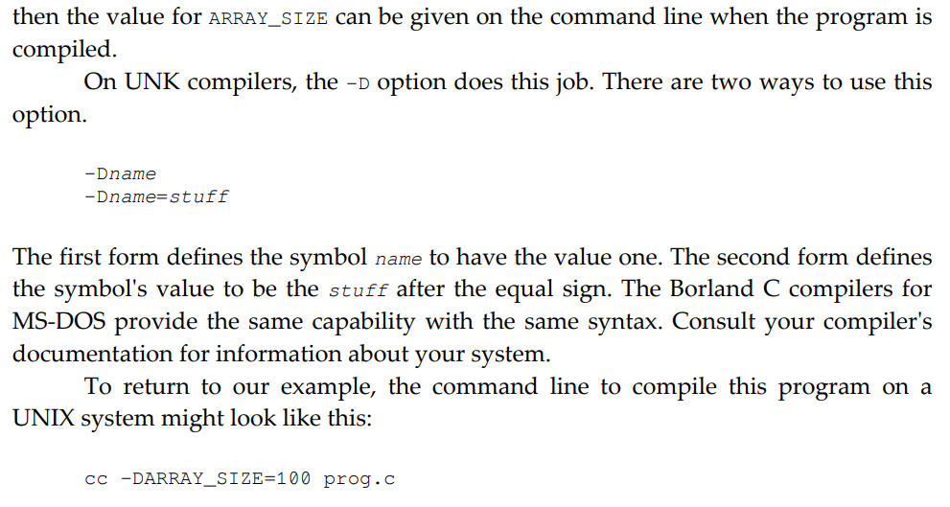

1. What is the difference between macro definition and typedef?

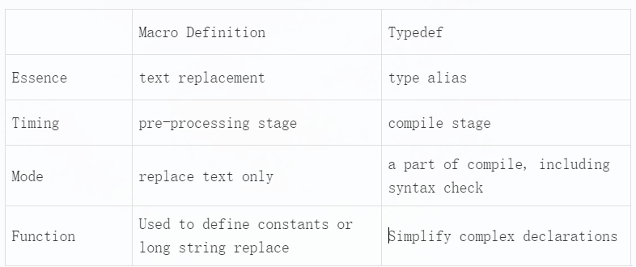

1. Both macro definition and typedef can help simplify code and improve its readability. However, sometimes they are different. What's the difference between them for the variables in the following program?

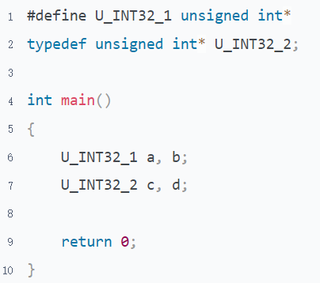

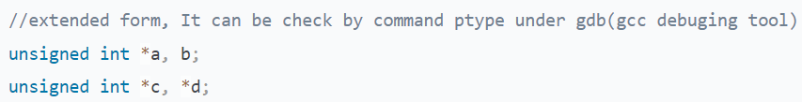

1. When do we need to use typedef? Illustration

* Used for pointer to improve program readability

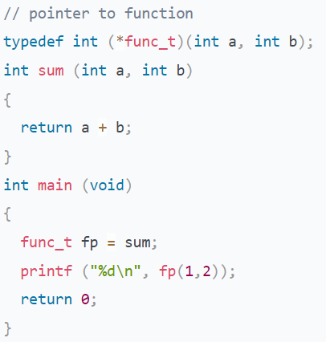

* Improve portability of program

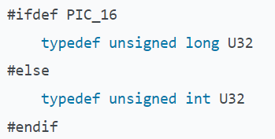

* Simplify complex definitions

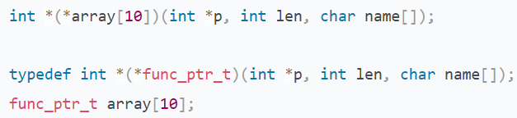

* Used to struct

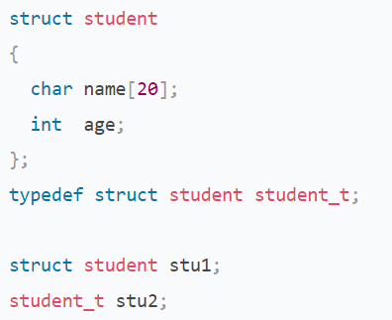

* Used to array

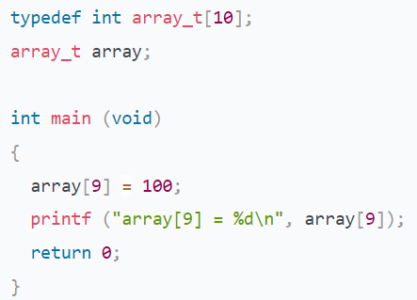

* Used to enumeration

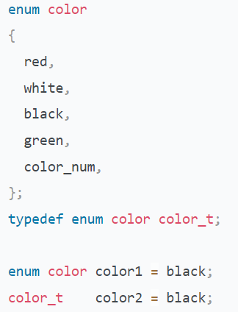

1. How to use conditional compilation to improve code portability?

Here is an example of conditional compilation from Linux about how to define machine width.

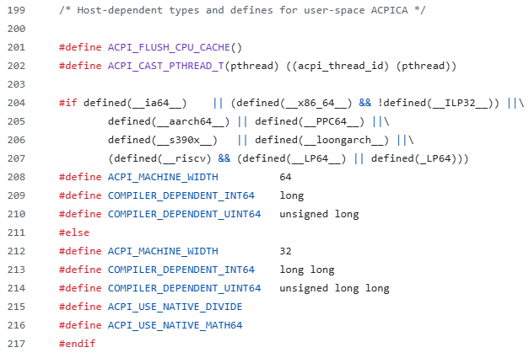

## Control Flow

### Guidance

* Chapter: Pointers-On-C.pdf Chapter 4; The-C-Programming-Language-2nd.pdf 3
* Spend time: 1 day
* Learn suggestion: Don't arbitrarily use the goto statement if you want to keep the program structure clear.
* Key points
  + What's the fall-through in the case statement?
  + What's the dangling in the else statement?
  + Why do we need control statements?
  + What is the execution order of the 3 parts of the for statement?
  + How can you convert between while and for?

### Practice

1. What is the function of control statements? What form can a control expression be?

A control statement is a statement used to control the selection, loop, turn, and return of a program flow. Control expression can be any form

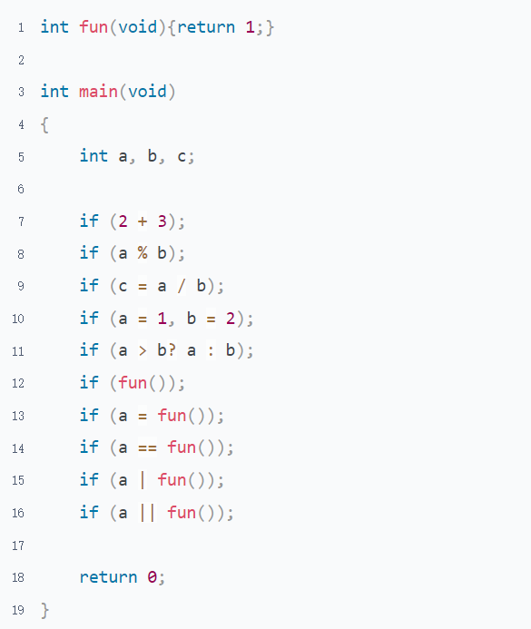

All used by if can also be used to while/for/switch/return.

1. How many kinds of selection statements are there? What are their application scenarios?

* It is simpler to use if when the value of an expression is range and to use switch when the value of an expression is definite

For example: A class will be graded according to the requirements of 0-59: E-level 60-69: D-level 70-79: C-level 80-89: B-level 90-100: A-level

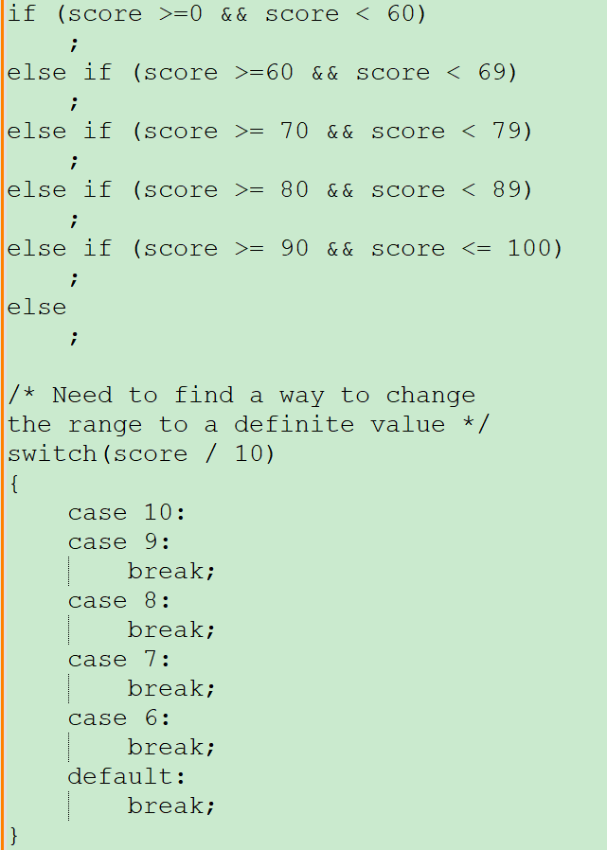

* It is easy to use “if” in multiple conditions
* The control expression of if use logical expression and switch use arithmetic expression. Because the result of a logical expression is 0 or non-0

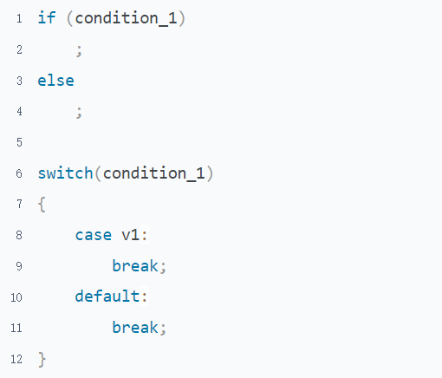

* Some compilers optimize the switch statement to make instruction execution more efficient.(Need more research)

1. What should we pay attention to in the switch statement?

* The value of the case must be an inter
* The case label must be unique
* Do not forget to add a break after the case statement otherwise a fall-through will happen
* Do not forget to add a default statement ending with all of the case, which can help you catch the case that you thoughtless
* The Statements aren't put in a case statement will not be executed

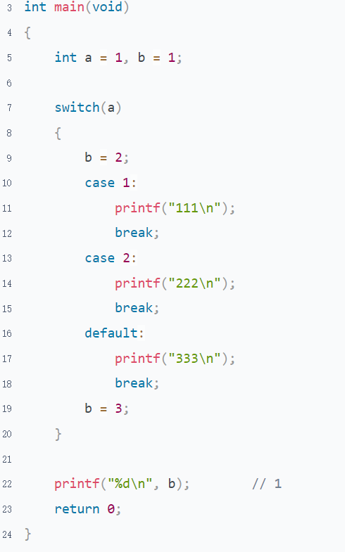

1. What is dangling-else? Illustration

The rule of an else match with it is that it will match with the if closest to it.

Therefore, Something will happen that is out of our expectations if we write if without braces

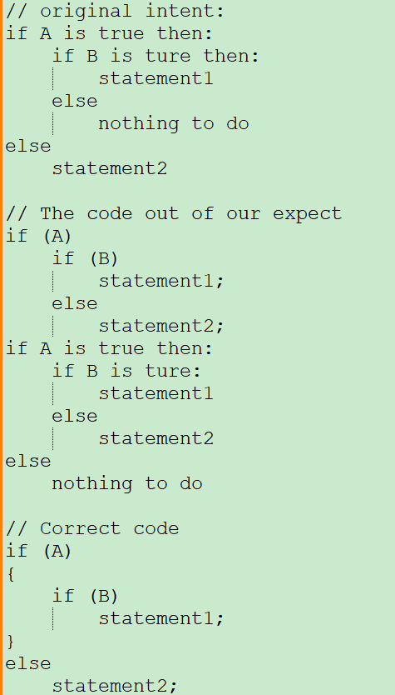

1. Pointers-On-C.pdf 4.13 question 4

There are 2 approaches can be taken in this case

* empty statements
* get logical not of the control expression

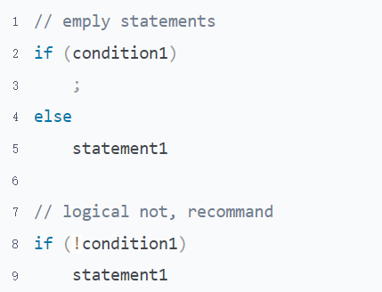

1. How many kinds of loop statements are there? What are their application scenarios?

There are 3 types of loop statements in C.

There isn’t any difference between for and while; they only look different in form and can be converted to each other.

In a particular case, they are better used in the following situations

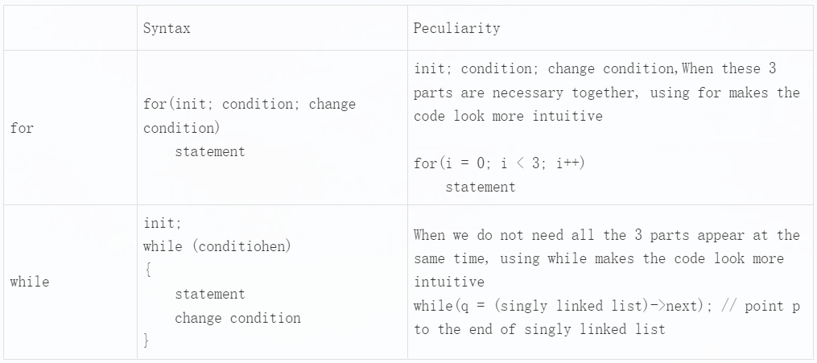

The only difference between the statement while and do while is the block code of do while will be executed at least once

1. What is the difference between break, continue and return when we use them in a nested loop? Illustration

Suppose, they all run in the innermost loop

* continue, skip this time loop of the innermost loop

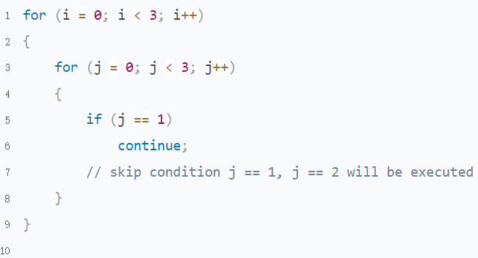

* break, skip out of the innermost loop to the second innermost loop

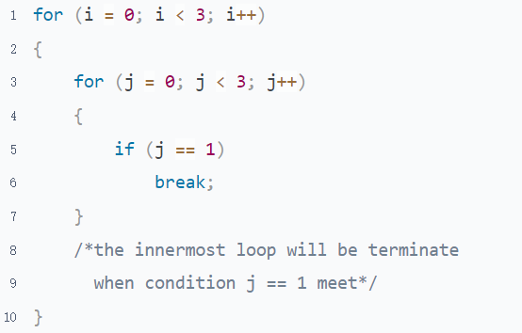

* return, skip out of all loop, there is a side effect to use return in nested. It causes the function to exit

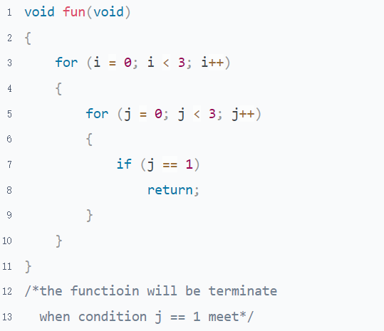

1. Pointers-On-C.pdf 5.8 question 8

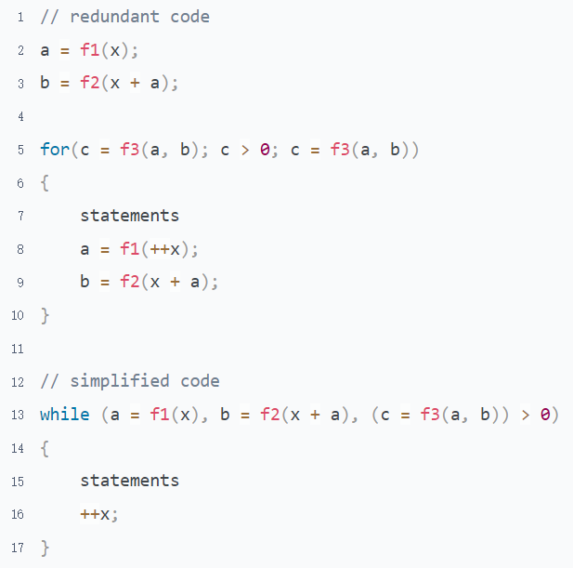

1. What are the advantages and disadvantages of the goto statement?

Advantages: Make the code flexibly jump within the function

Disadvantages: The goto statement breaks the C code execution structure, reducing the readability and maintainability of the code greatly. And affect the execution efficiency of machine instructions

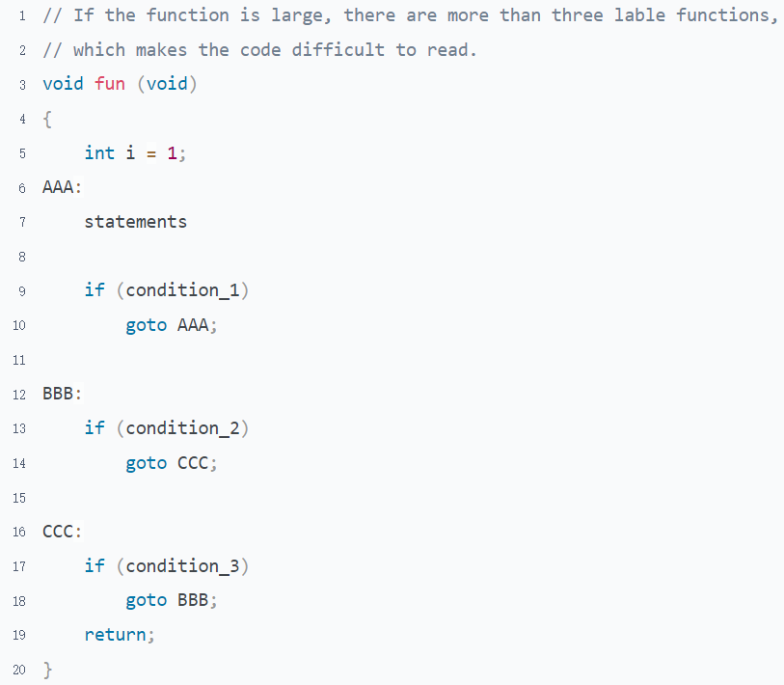

* The first situation in which the use of goto is recommended. When a function exits and needs to do some work on resource cleaning classes and Don't break the code structure, using goto makes the code leaner

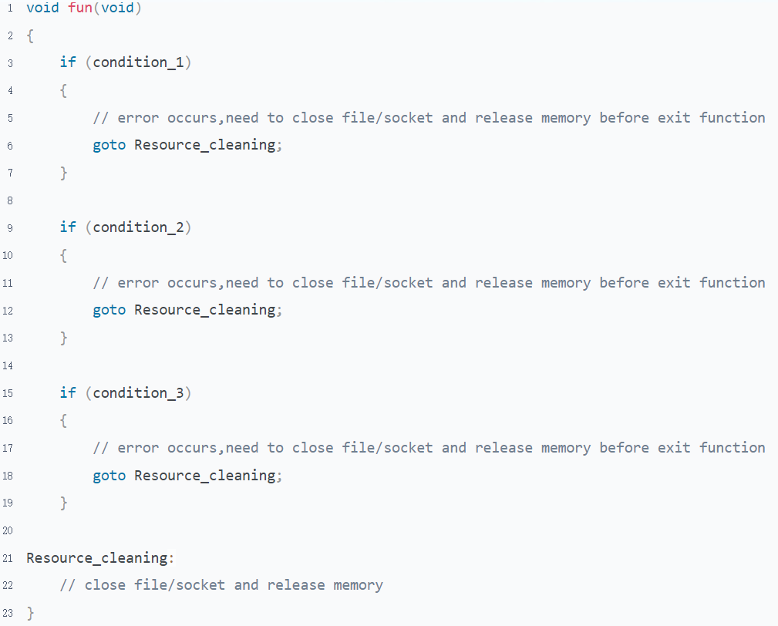

* The second situation in which the use of goto is recommended. Goto can be used to help code jump out of nested loop.

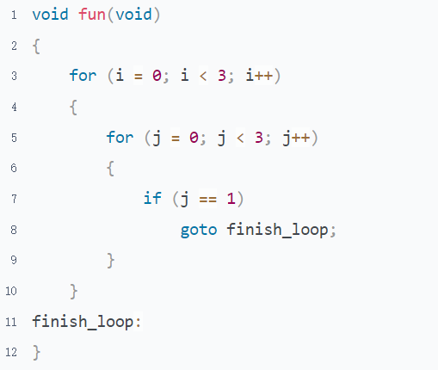

## Input & Output

### Guidance

* Chapter: Pointers-On-C.pdf 15; The-C-Programming-Language-2nd.pdf 7
* Spend Time: 1 day
* Learn Suggestion: Try to build a strong awareness of buffer
* Key Points
  + What are the standard input/output/error?
  + What's the input/output buffer? Why do we need it?
  + How to format string/digital when Input/output? Figure 15.1-15.2, Table 15.3-15.7 of Pointers-On-C.pdf(Important)
  + The basic operation of file operation

### Practice

1. Why do we need to know the output buffer? How many ways to flush the output buffer?

The output buffer is used to temporarily store output data to prevent frequent generate interruptions and improve cpu efficiency. But there is one caveat when using output buffer. If it isn't refreshed before some fatal errors. You may not get the output.

There are several ways to flush the output buffer

* The buffer will be flushed when the process is exit

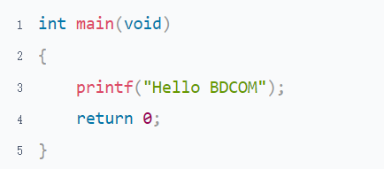

* The buffer can be flushed by a newline character

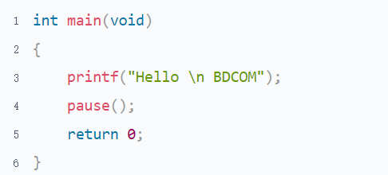

* The buffer can be flushed by the library function fflush

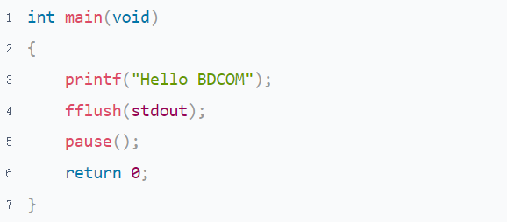

1. Which library functions may cause overflow in Table 15.1 of Pointers-On-C.pdf? How can we prevent it from occurring?

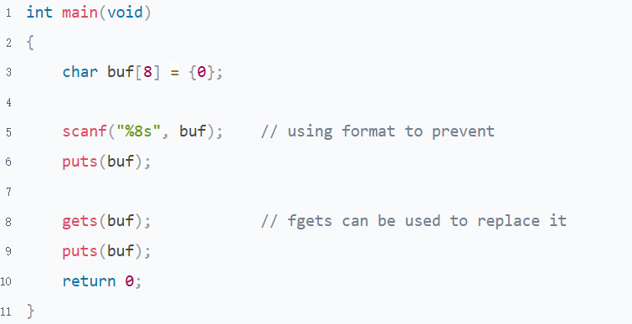

1. Get the output based on the given data

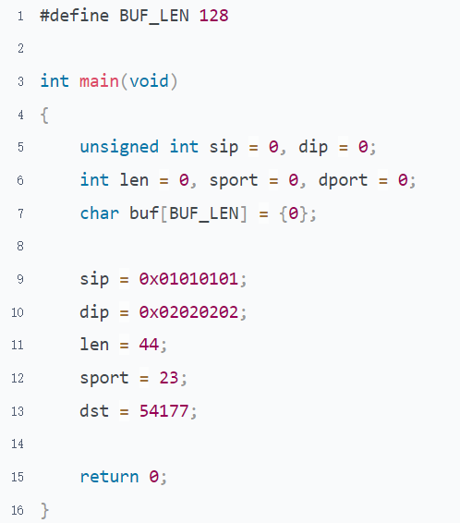

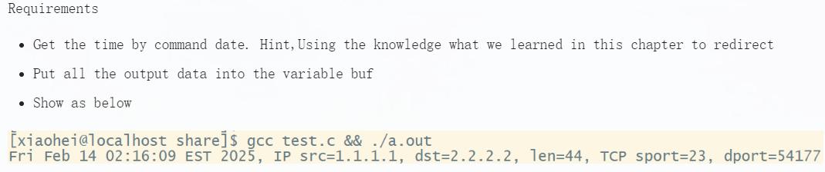

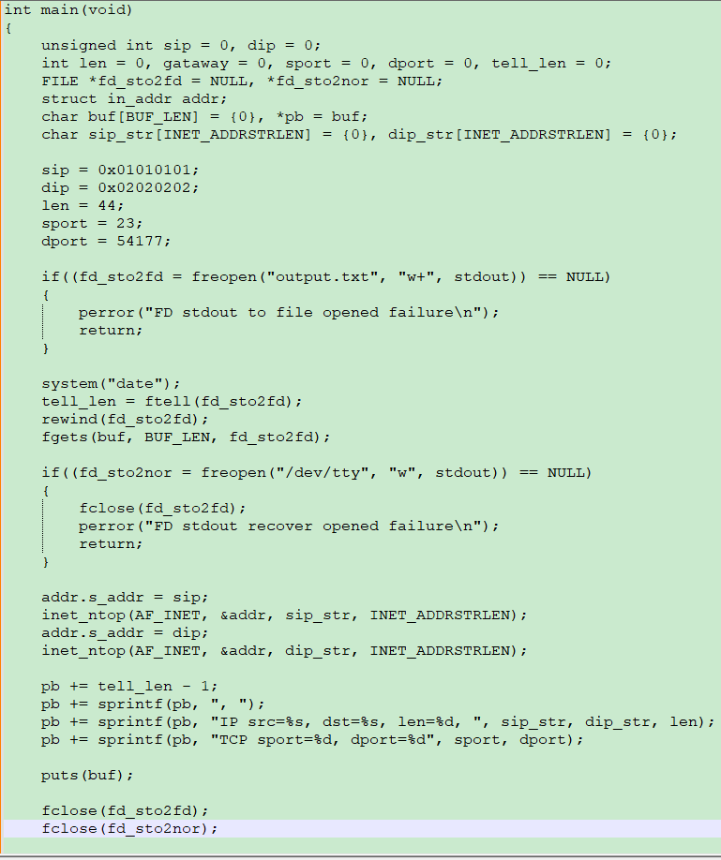

1. There is a file whose name is input.txt; it is calculated that the file length is n. Copy the part n/2-n to file output.txt. As efficient as possible

Suppose the file length is n, copy n/2-n to file output.txt.

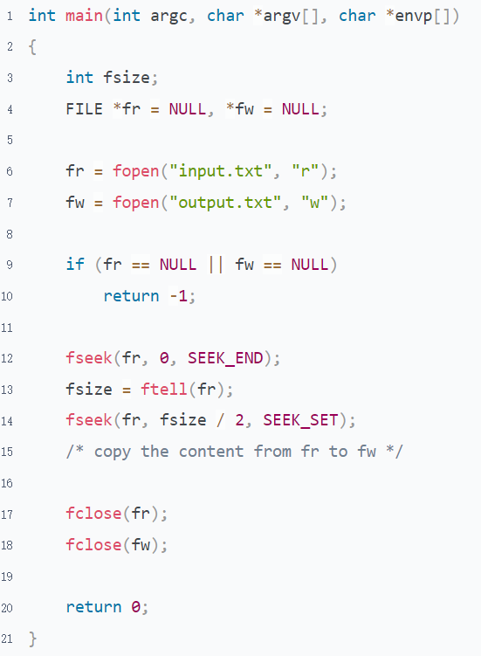

1. List out all options of the fopen that you know and their descriptions

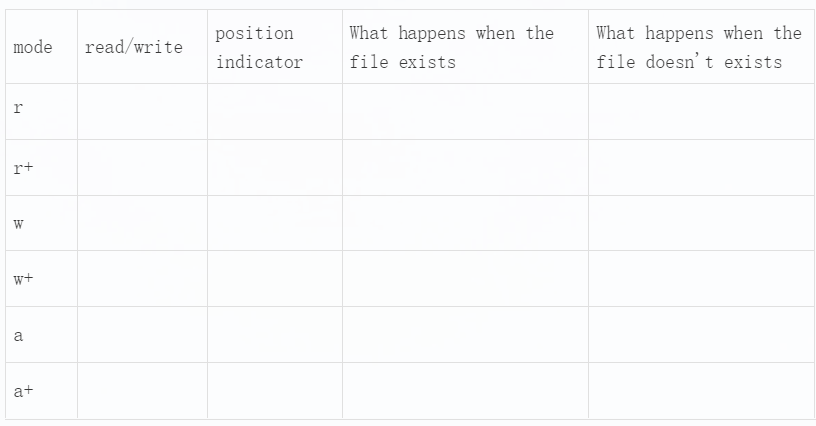

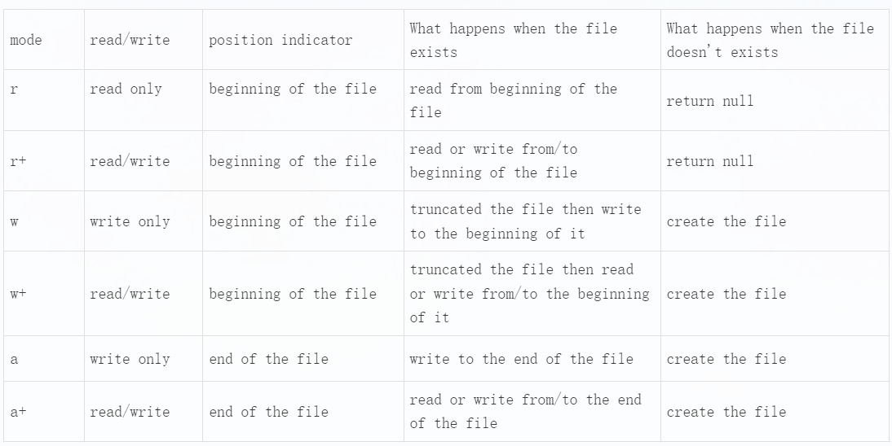

# Topic 3: Representation Of Data

## Byte Order

### Guidance

* Chapter: Computer-Systems-A-Programmers-Perspective.pdf 2.1.3 2.1.4;<https://teaching.idallen.com/cst8281/10w/notes/110_byte_order_endian.html>
* Spend Time: 1 day
* Learn Suggestion: Do the experiments in both little/big endian environments
* Key Points
  + How is the data stored in different byte order platform?
  + What's the relationship between big-endian/little-endian/host order/network order?
  + How does the string storage on different byte order

### Practice

1. What are the rules of big-endian and little-endian? Illustration

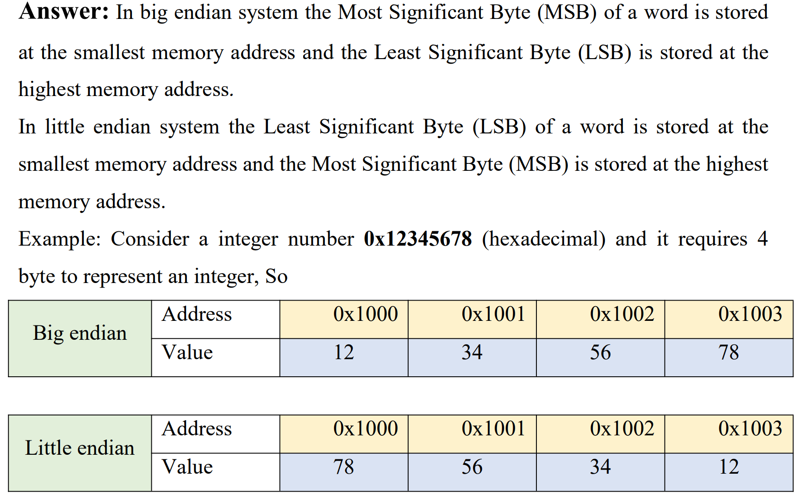

1. How many ways to determine the byte order of your PC? Illustration

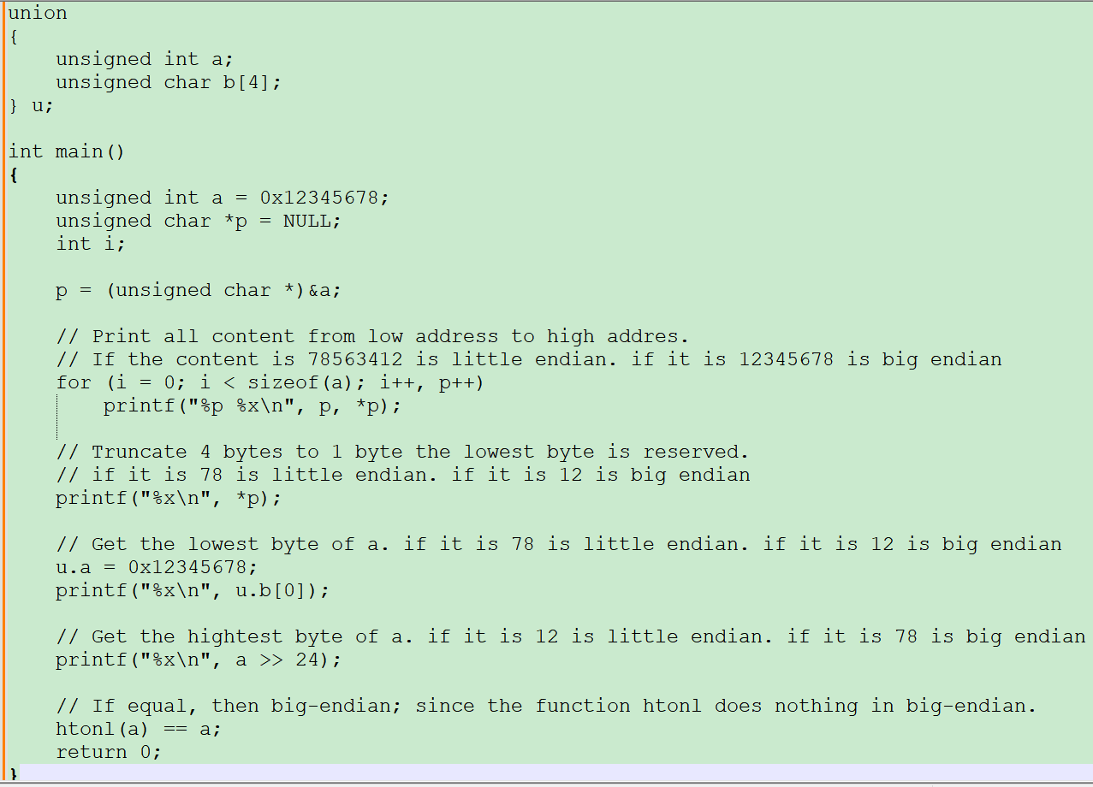

1. Computer-Systems-A-Programmers-Perspective.pdf Problem 2.6

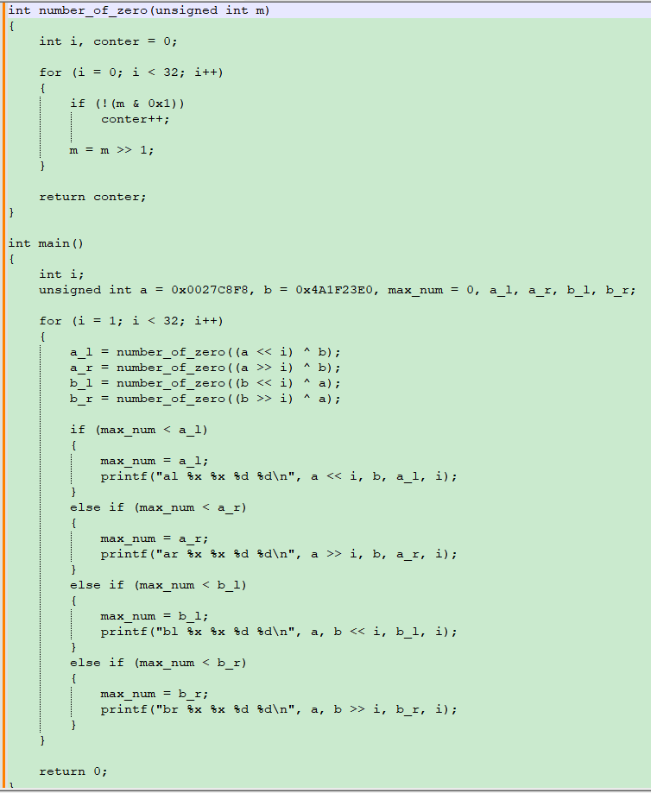

1. Here is a bunch of data from the network(big-endian). Parse and print it following the format as the image blew to ensure it can run properly.

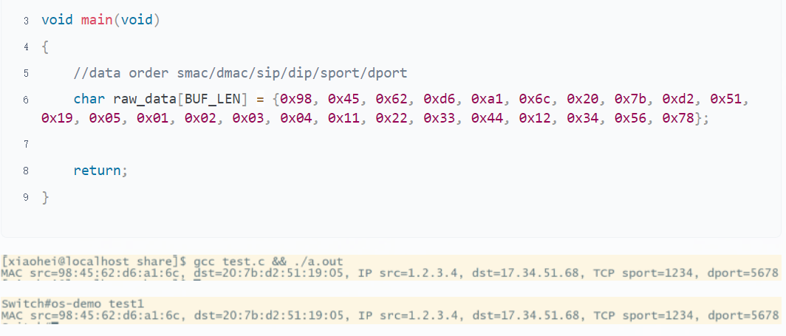

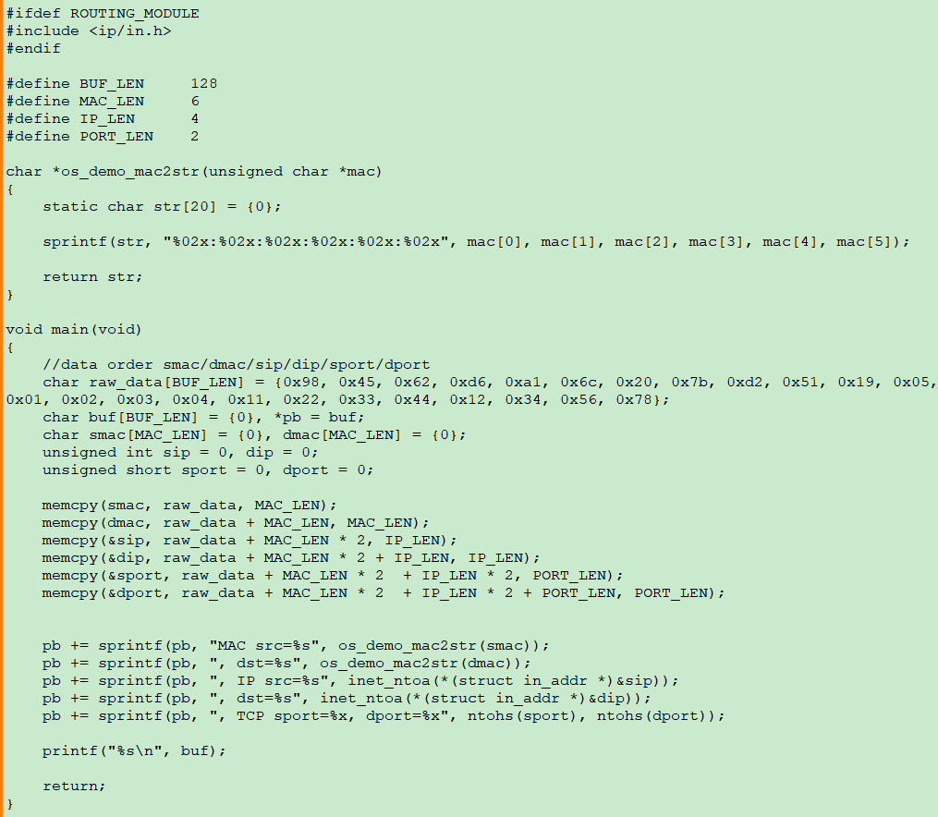

## Data Storage & Representation

### Guidance

* Chapter: Pointers-On-C.pdf 3.1.1; Computer-Systems-A-Programmers-Perspective.pdf 2.1.2 2.2.1-3 2.2.4-7
* Spend Time: 1 day
* Learn Suggestion: To know exactly how the data is stored and represented in the memory.
* Key Points
  + What are the extension and truncation of data store?
  + What is the difference between implicit type conversion and explicit type conversion?
  + How does the computer store negative numbers?
  + What is the rule of 2's complement operation?

### Practice

1. What is the difference between the following 2 values in memory? Are they the same or not? Why?

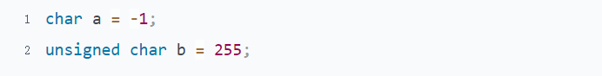

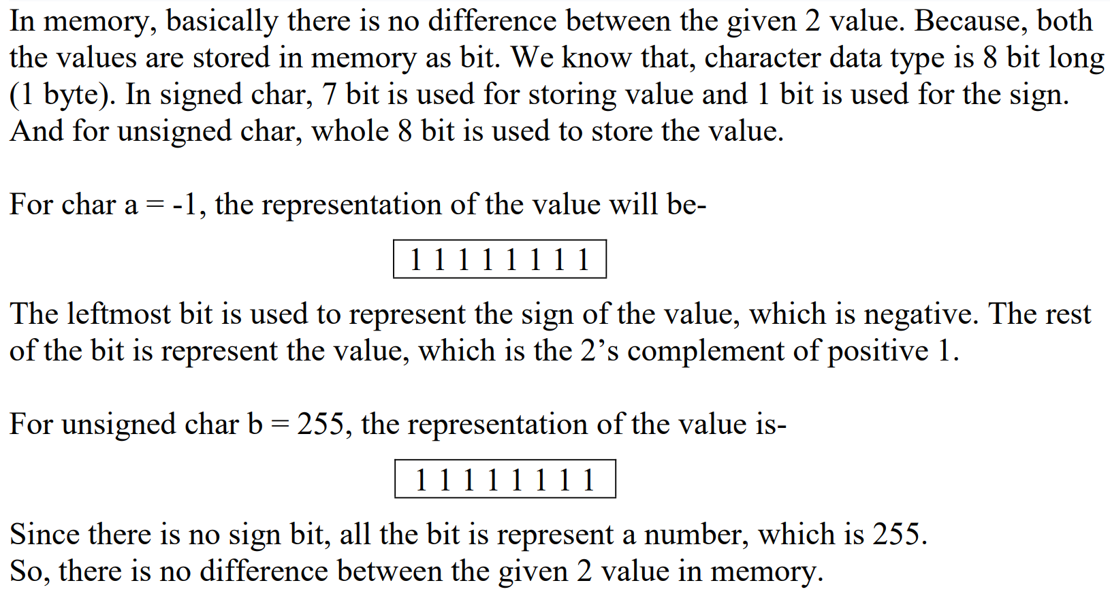

1. Try to explain why the result of the following program is that way. What happened?

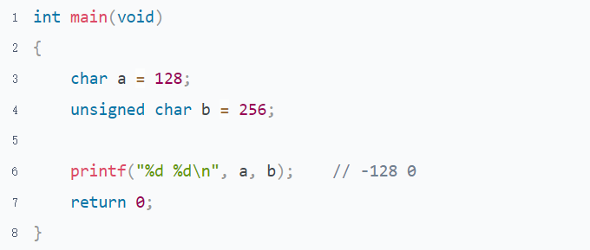

Char data type is 1 byte long. For signed char, 1 bit is used to represent the sign of the number, and other 7 bit is used to represent the value. So, the range of signed char is -128 to + 127. For char a = 128, if we represent it in binary form, then this will look like

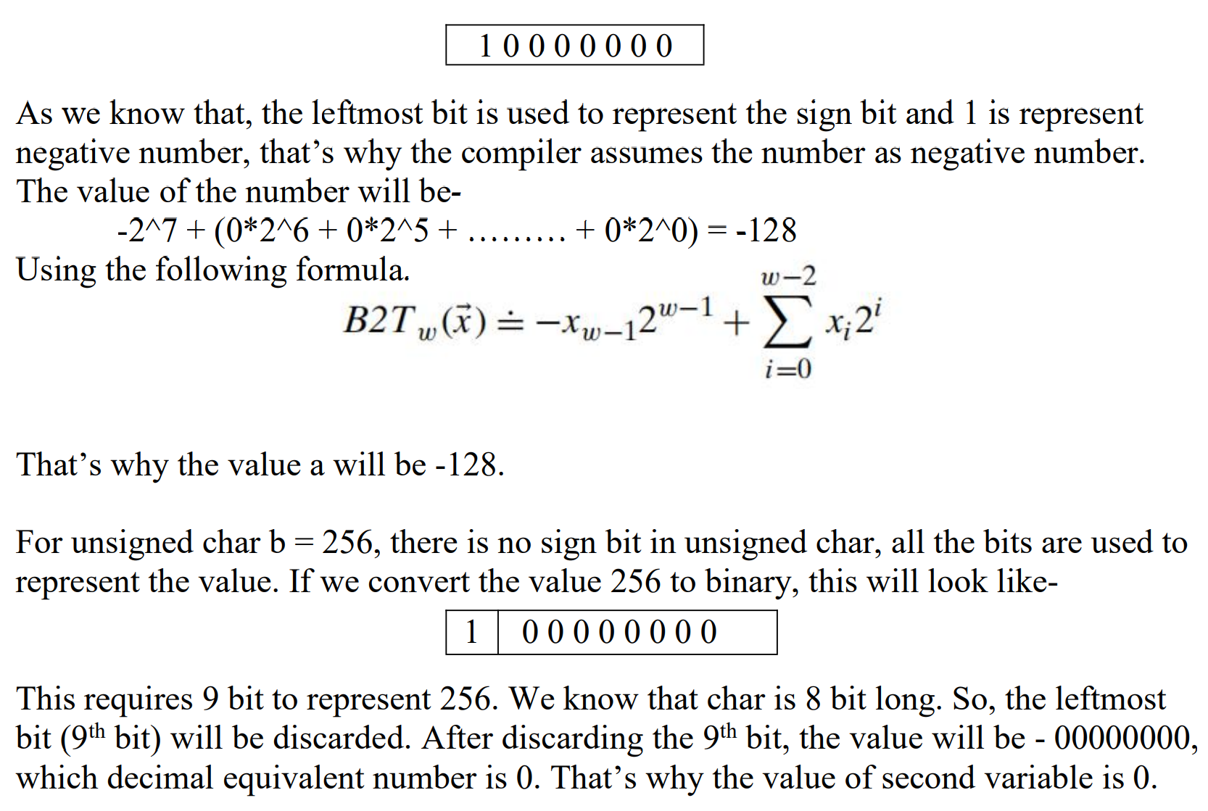

1. What is an extension when storing a number? When does it occur?

When the length of the converted original type < the length of the destination type, the destination storage space cannot be filled, then it needs to be extended.

There are two cases of extension

* 1. For signed types, the highest bit copy needs to be filled in the remaining space, which is called symbol extension.

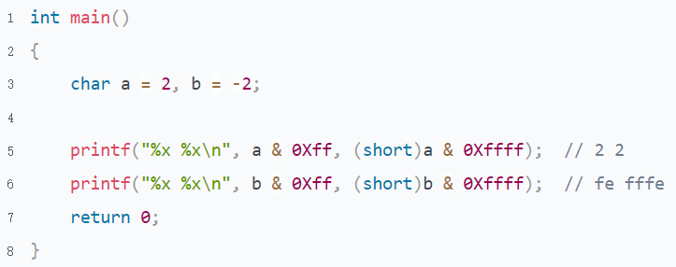

* 1. For unsigned types, fill the remaining space with 0, which is called 0 extension

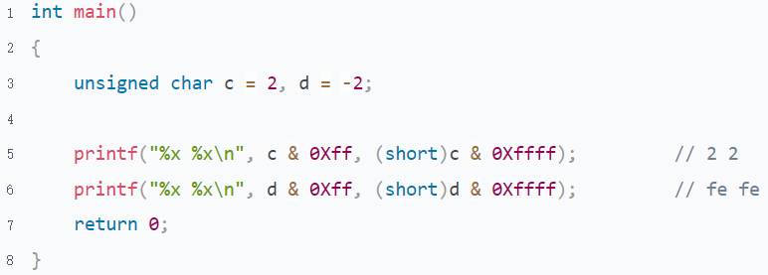

1. What's an integer promotion? What's the rule of it? What scenarios does it occur?

Integer Promotion：In an expression, Any value range of the original type that can be represented by type int is raised to int. else raised to unsigned int

long long->long->int

In an arithmetic operation, as long as the type of one side is the above type, the other side is also promoted to this type. If not any side is of any of the above types, it will be promoted to int according to the principle of integer promotion.

To know more, search for "Integer Conversion Rank" on the google

* Default Promotion

The default type is an integer to store a data even though it's only a character.



* Usual Arithmetic Conversion

promote the type of c1,c2 and c3 to int. then do arithmetic

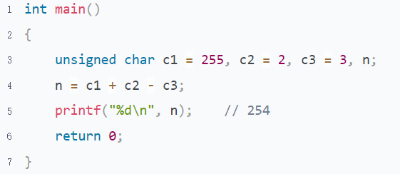

* Function calling procedure

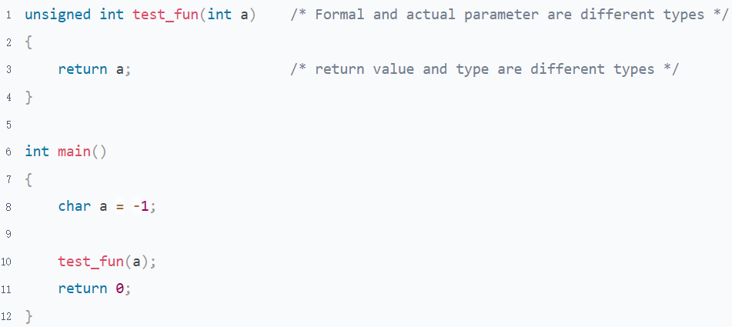

1. What happened in the following program when the argument length is 0? Why?

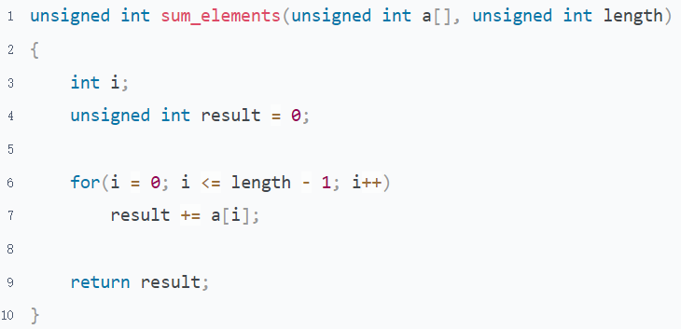

The process is crashed

* Why did the process crash?

Invalid memory space may be accessed due to an infinite loop causing the array to overflow.

* Why does the infinite loop happen?

i <= length - 1,The unsigned int type participates in this expression, and according to the rule of integer promotion, all data type become unsigned int. When length is 0，0-1 equal to -1，It is 0xffffffff in unsigned int. The range of i is 0-0xffffffff.

Therefore the expression i <= length - 1 is true forever

## Bitwise Operation

### Guidance

* Chapter: Computer-Systems-A-Programmers-Perspective.pdf 2.1.6-2.1.9;C-Primer-Plus.pdf chapter 15 C’s Bitwise Operators
* Spend Time: 1 day
* Learn Suggestion: Build awareness to save the memory in the embedded system as much as possible.
* Key Points
  + What's the difference between logical shift and arithmetic shift?
  + What's the difference between bitwise and logical AND/OR/NOT?
  + The truth table for Bitwise AND/OR/NOT/XOR

### Practice

1. Pointers-On-C.pdf 5.8 question 12

There are 2 kinds of ways used for a right shift in C, arithmetic or logical shift. The rules are as following

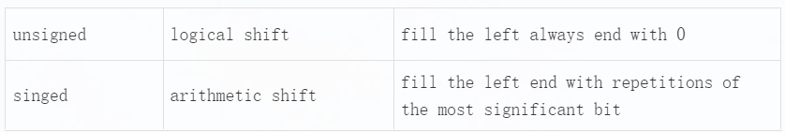

More detail to reference Computer-Systems-A-Programmers-Perspective.pdf -> 2.1.10

For the current question, we can determine to use the program as following

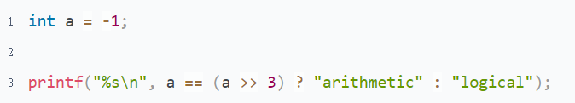

1. Computer-Systems-A-Programmers-Perspective.pdf Practice Problem 2.16

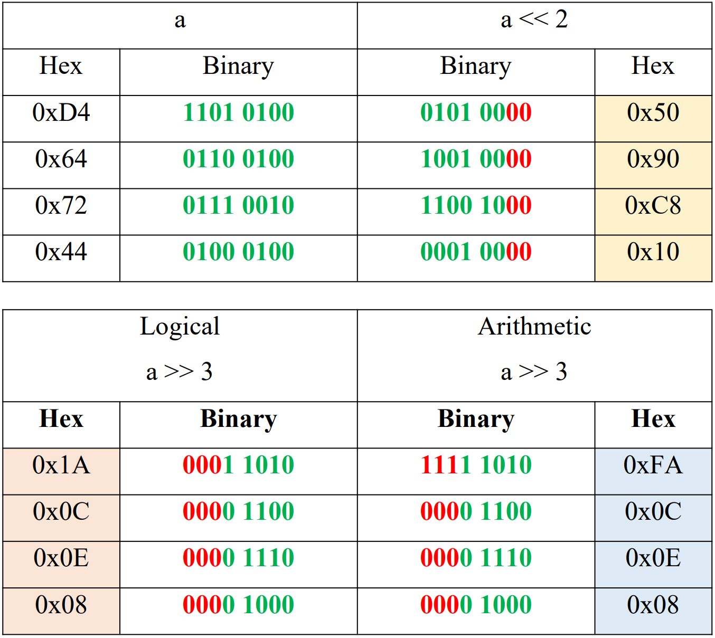

1. Computer-Systems-A-Programmers-Perspective.pdf Practice Problem 2.13

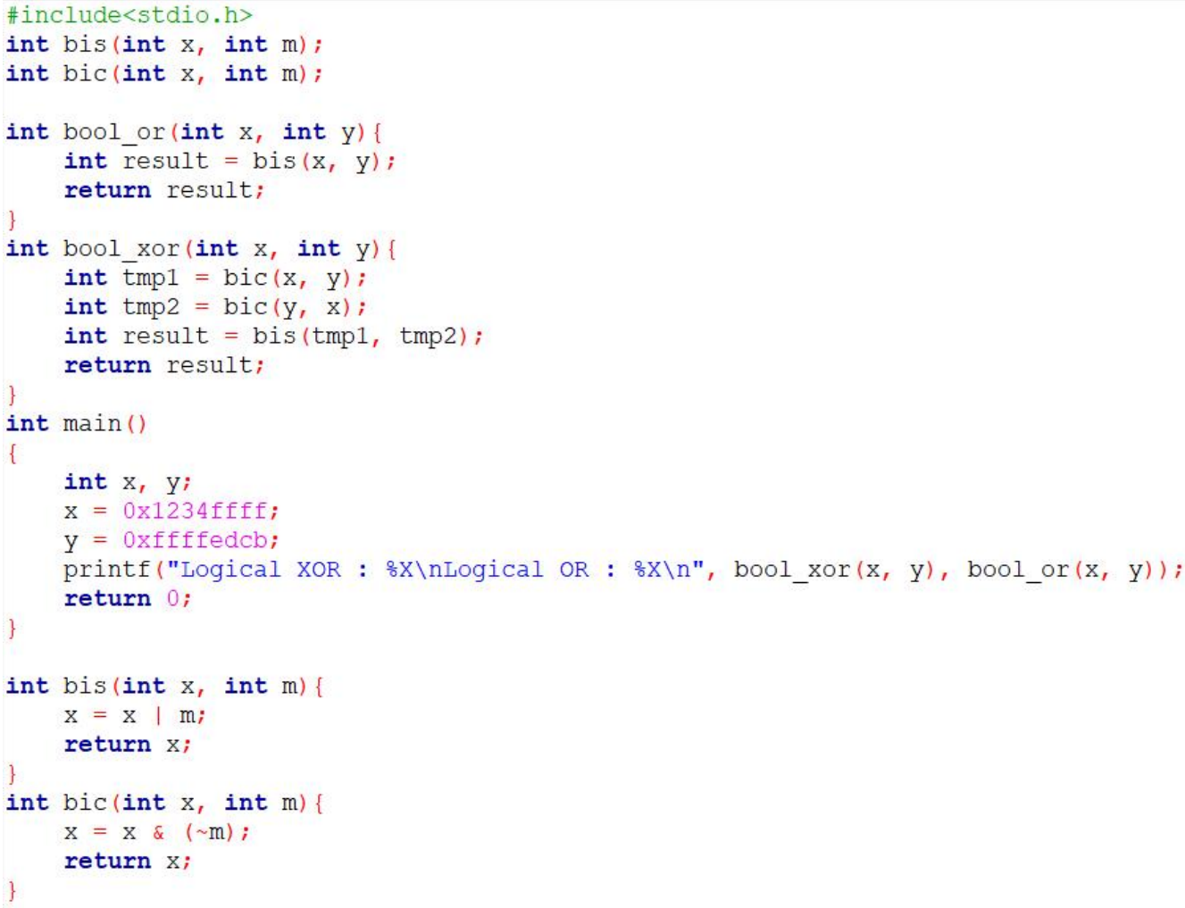

1. Pointers-On-C.pdf 5.9 question 4

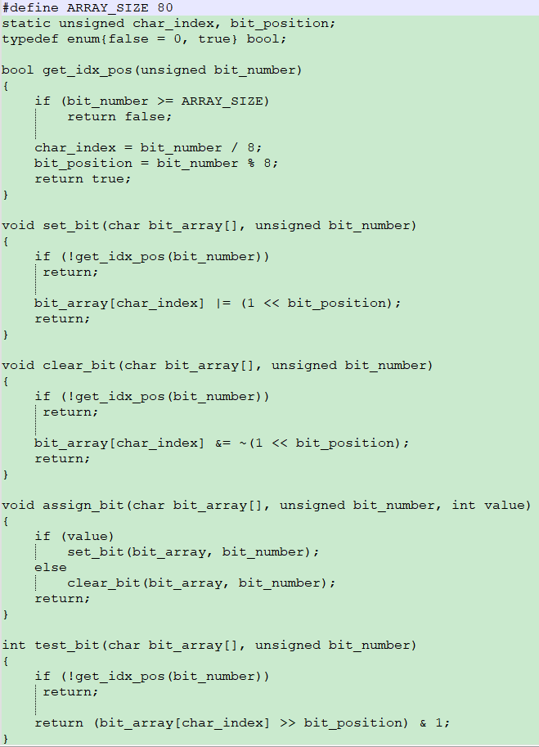

1. Pointers-On-C.pdf 5.9 question 5

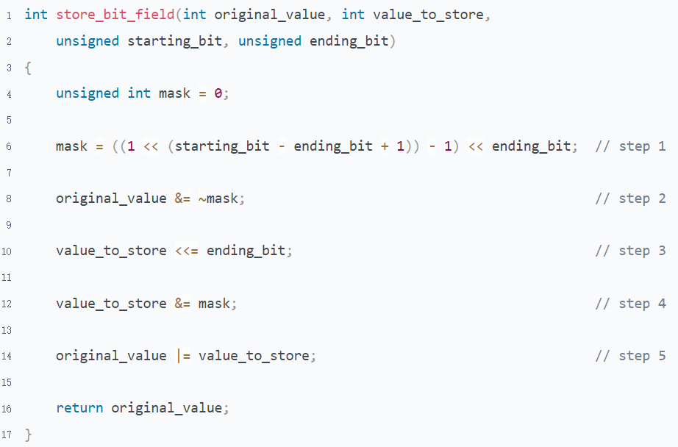

# Topic 4: Compound Type

## Array

### Guidance

* Chapter: C-Primer-Plus.pdf Chapter 10(Skip pointers section); Pointers-On-C.pdf chapter 8.2.1-8.2.3
* Spend Time: 1 day
* Learn Suggestion: Learning from the perspective of the memory
* Key Points
  + What is compound type? Why do we need compound type?
  + How is an array stored in memory? What about a multi-dimensional array?
  + What scenario does an overflow may occur? What might it lead to?

### Practice

1. What is the physical structure of the array? How is the array stored in memory? Why is the index of the first element of the array [0] instead of [1]?

The index is the offset of the start address of the element in the array relative to the start address of the array

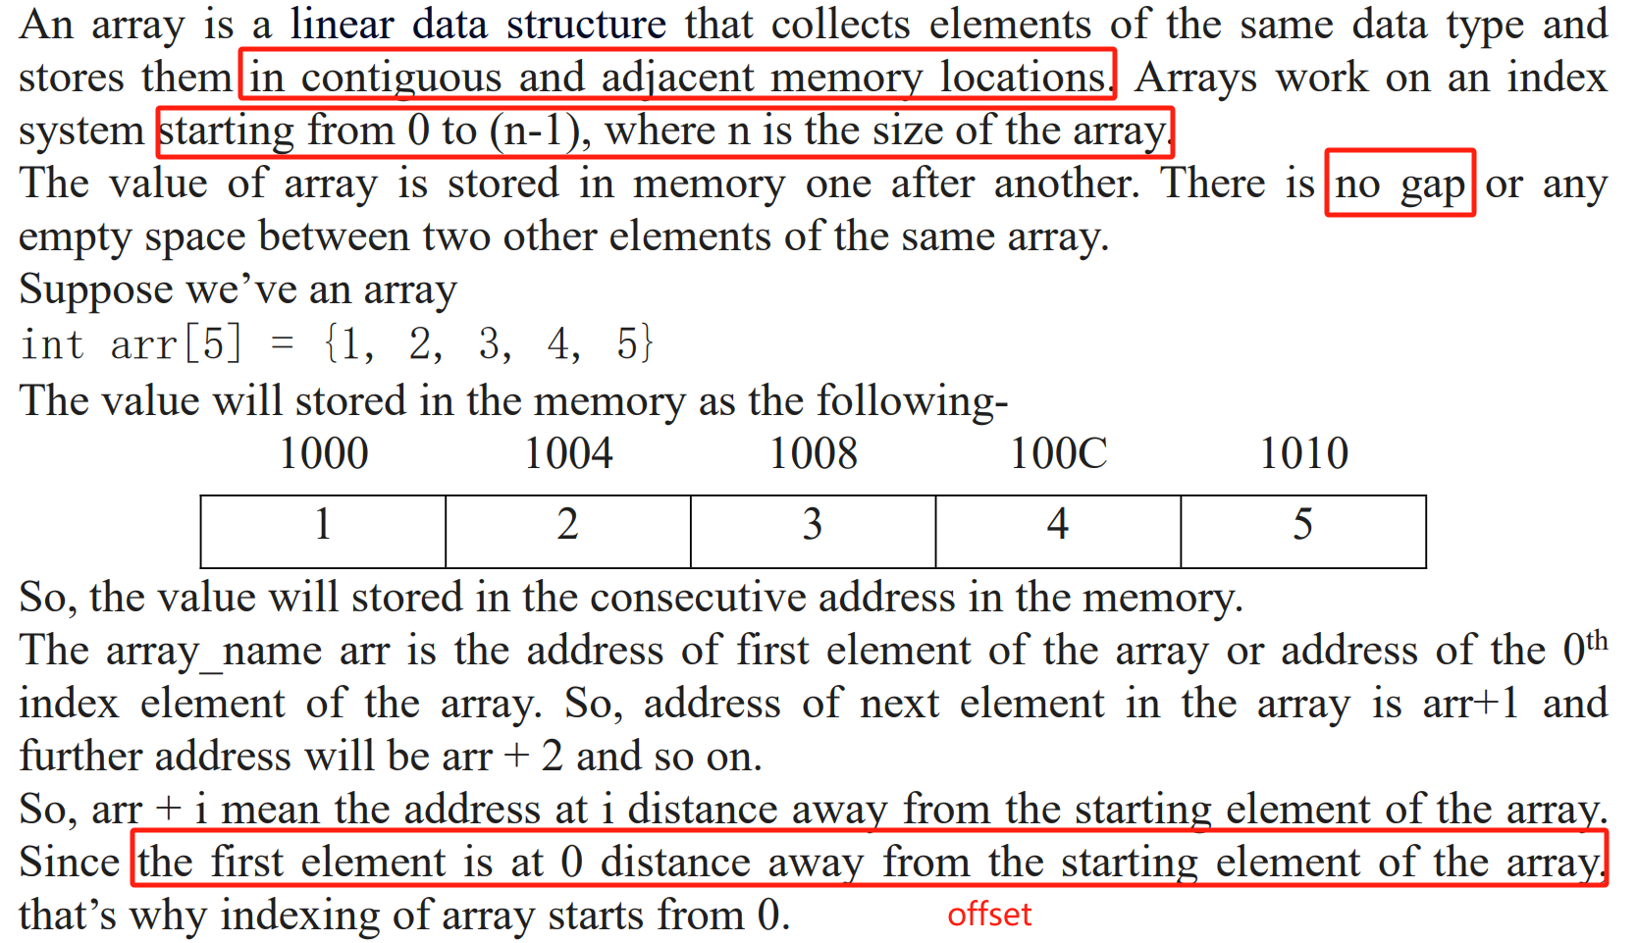

1. What happens if an array overflows? Illustration

It will overwrite the data of the neighbor when the array overflow occurs. resulting in incalculable consequences.

If the array is stored on the stack, it may destroy the key information on the stack, leading to a function call stack mess. For example, the return address may be overwritten.

If the array is stored in a global area, it may destroy the global variable table, leading to more serious effects.

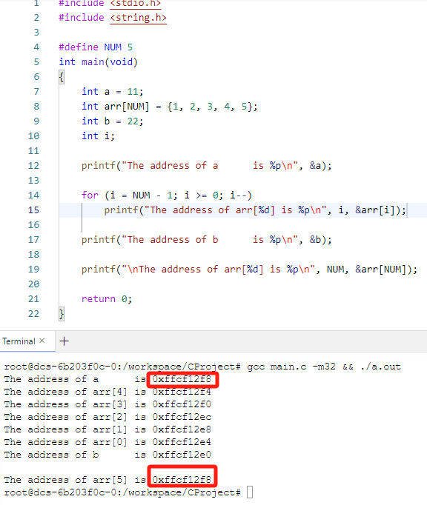

1. What can you learn from the following program?

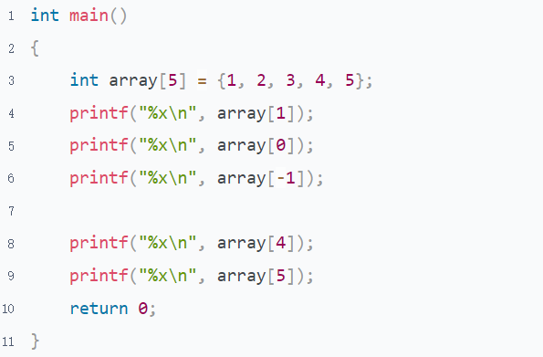

We can find that the C compiler did not have any restrictions for the array index; you can access the array by any index. Because the designers of C thought that C programmers knew exactly what they were doing. There is no need to restrict him in this regard. So, as a C programmer, we need to know exactly what we are doing now

1. Briefly describe the storage and access of multi-dimensional arrays

A multidimensional array stores data in a row-major order in C. Based on this, there is no difference in memory between a one-dimensional and multidimensional array when they have the same number of elements.

The following program's multidimensional array can also be initialized using one-dimensional arrays. Multidimensional arrays are just a form of data representation that exists only to facilitate developers' better implementation of their business.

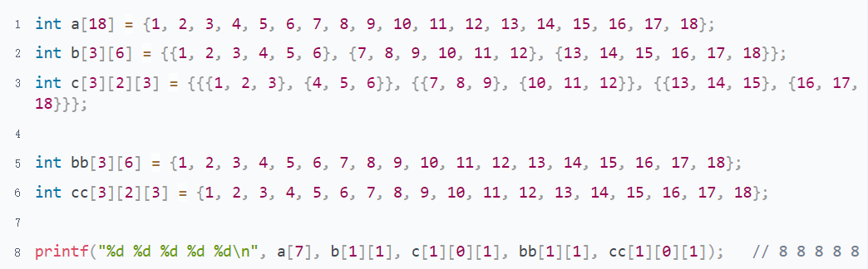

.

Here is an explanation of row-major order and column-major order

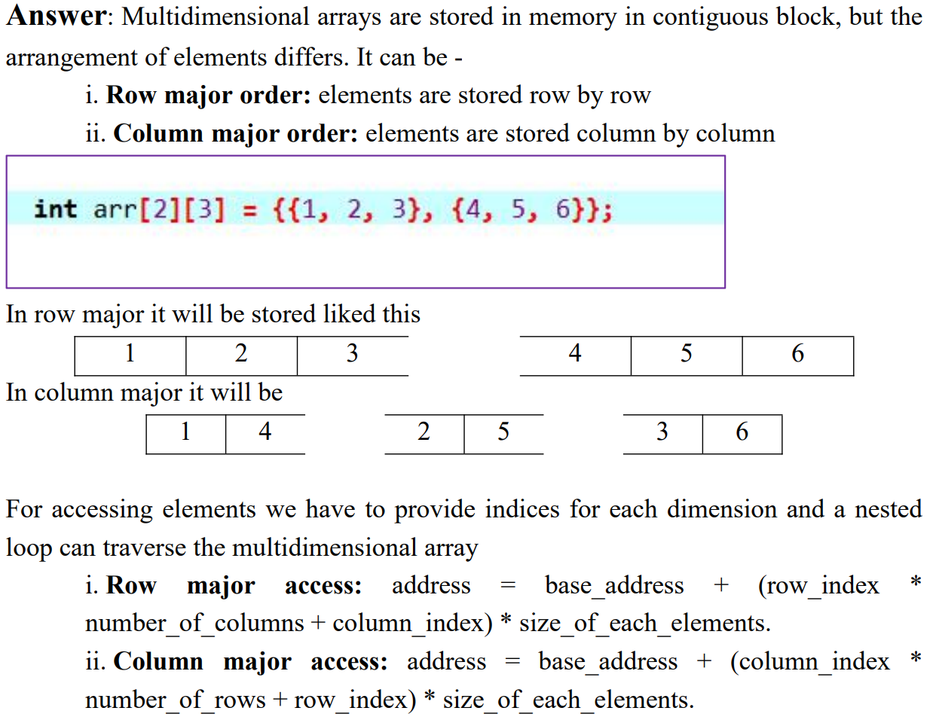

1. Draw some images to demonstrate the memory structure of array1/array2 and the output in the following program. Which can help a person know well how the memory stores an array

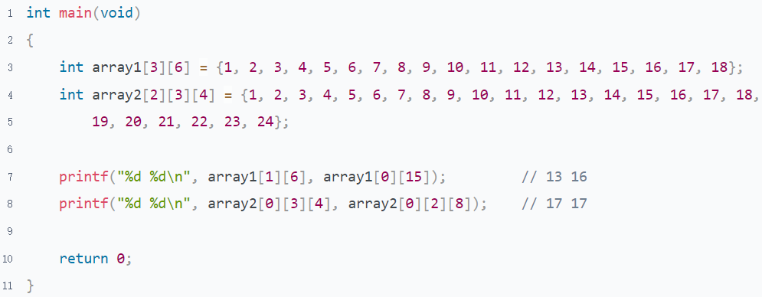

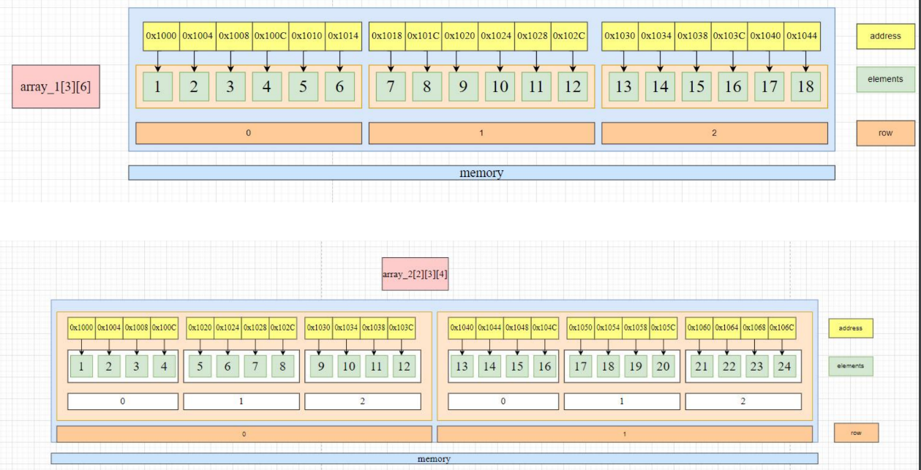

## String

### Guidance

* Chapter: Pointers-On-C.pdf chapter 9, 13.5
* Spend Time: 1 day
* Learn Suggestion: To know well, how the library functions that start with 'str' work in the header "string.h"
* Key Points
  + How to store a string in C? Is there a string type?
  + What is the difference between the c sizeof and strlen?
  + What is the meaning of 'n' in the library function strncat/strncmp and strncpy?

### Practice

1. How many ways to store a string "Hello World!" in C? Where are they stored? Lists all the different memory storage ways in which this string can be stored

Refer to "String storage.c"

1. What is the difference between strcpy and memcpy? Illustration

* strcpy: Copy from source to destination character by character until 0 character is encountered
* memcpy: Copy a specified number of bytes of data from the source to the destination

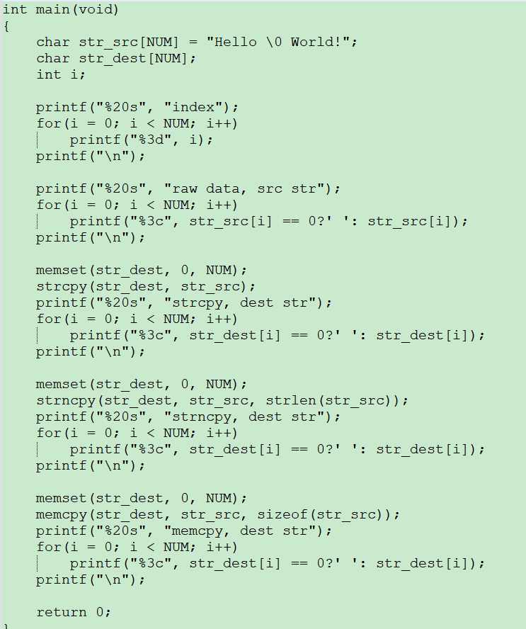

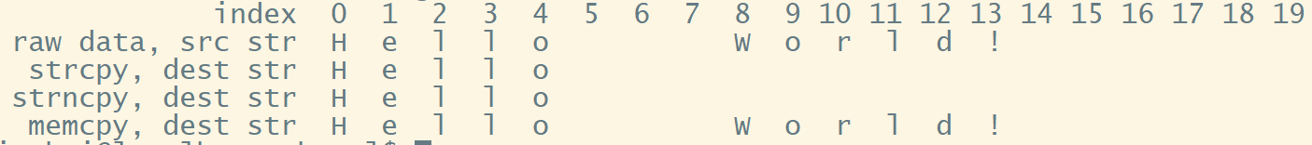

1. Pointers-On-C.pdf 9.14 question 3

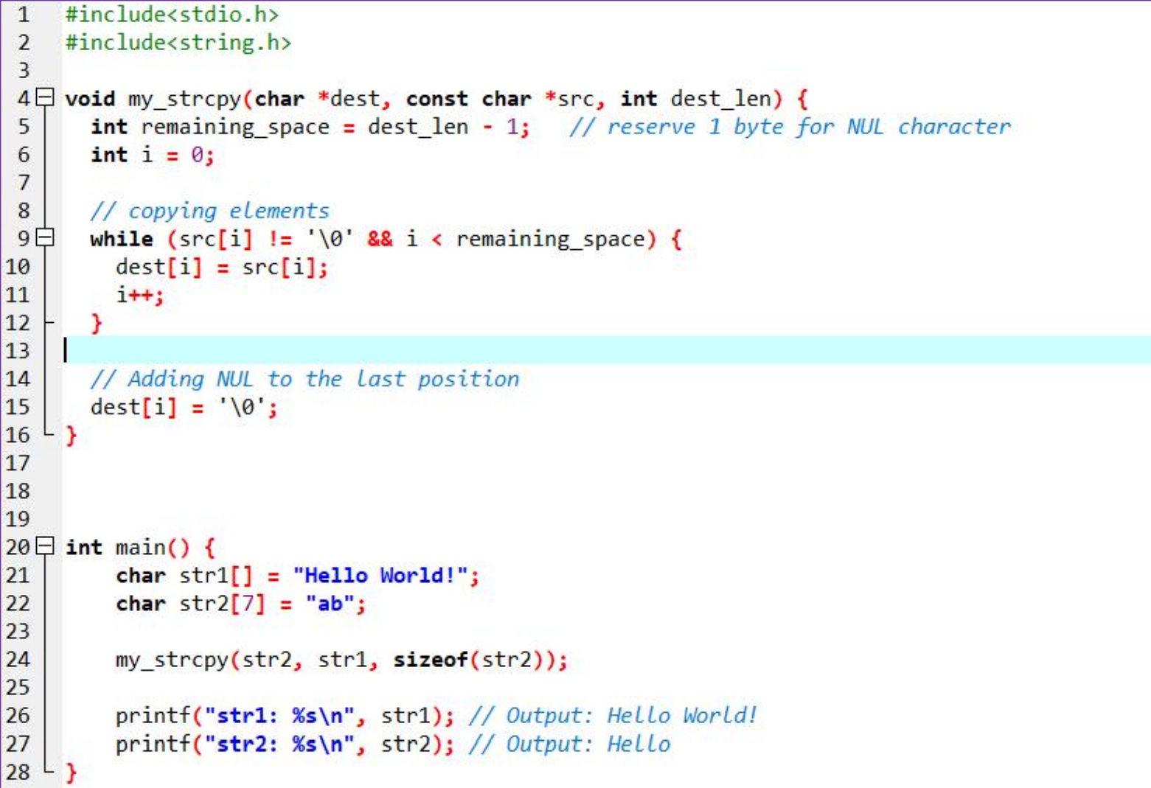

1. Pointers-On-C.pdf 9.14 question 5

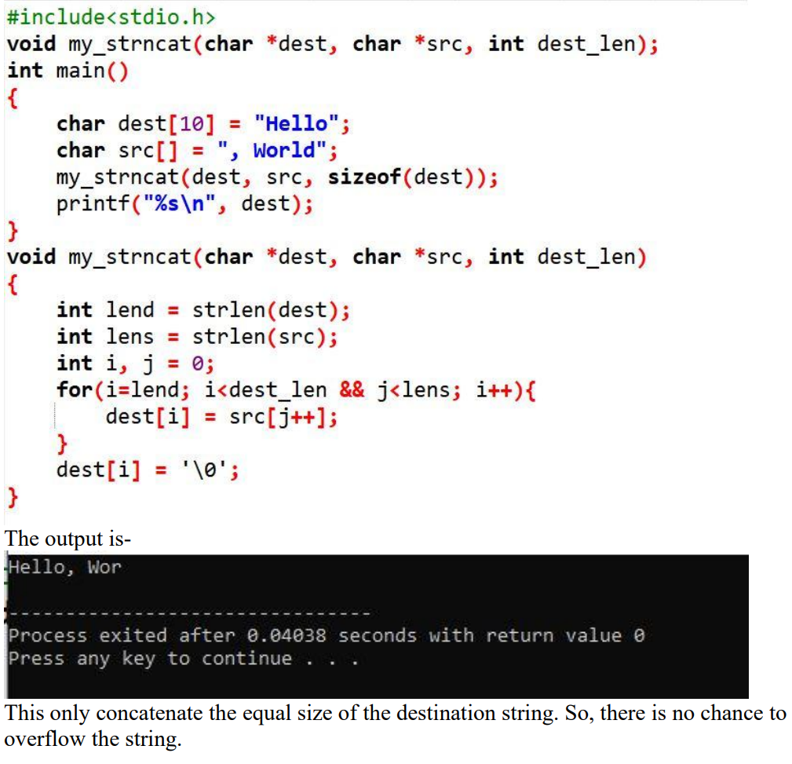

1. Find the average

There are 8 people in the group, and the current C language test scores are 210, 327, 413, 57145, 9154, 163, 23172, and 4081. The current device is an 8-bit-based PC, the maximum size is 8 bits. Only uint8 is available. You are allowed to use arrays, structs, or other simple variables. Please provide the average score of these 8 people.

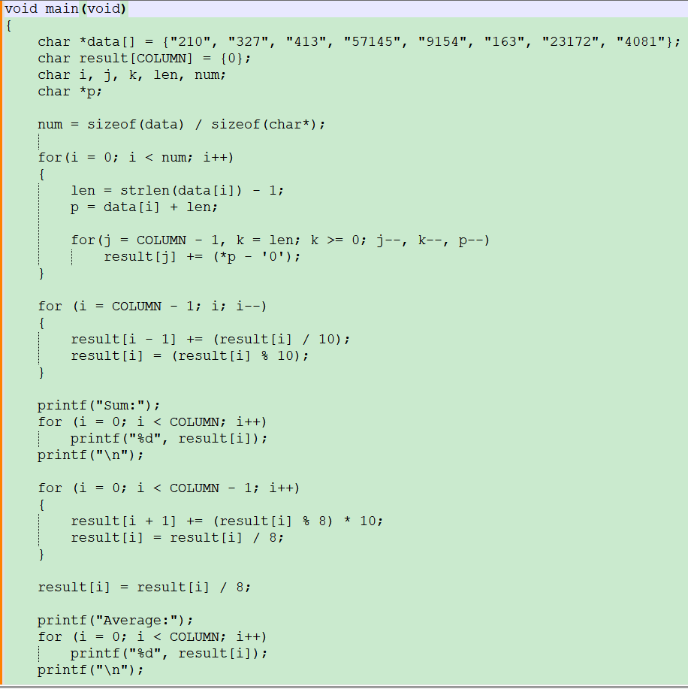

## Struct

### Guidance

* Chapter: Pointers-On-C.pdf chapter 10; Align And BE_LE Endian.docx
* Spend Time: 2 days
* Learn Suggestion: Try to read some open-source codes. To learn how they are implemented.
* Key Points
  + Why do we need a struct? What is it used for?
  + How to use the bit field to save the memory? What's the difference is it in big/little endian device? How to write a program for a bit field that doesn't need to consider byte order?
  + What's the alignment? Why do we need it?

### Practice

1. What is the difference between aa, bb and cc?

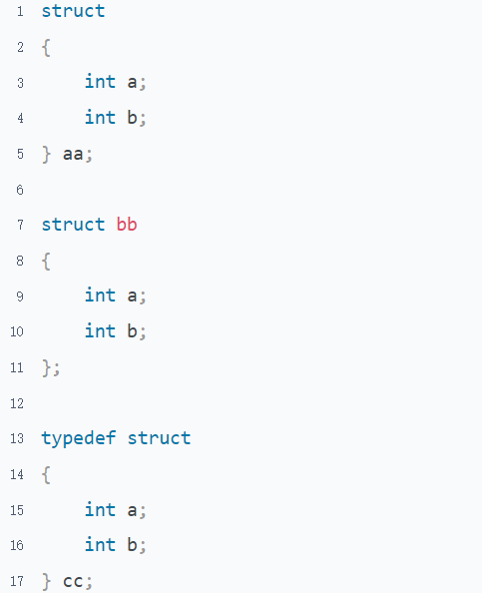

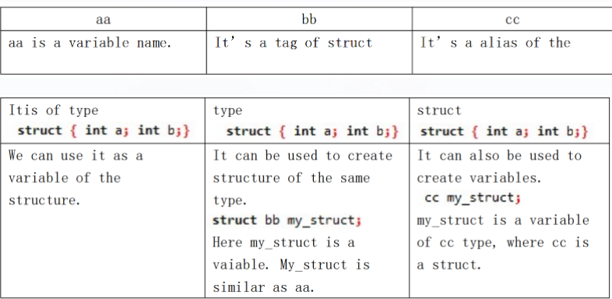

1. How many ways to initialize a struct? Illustration

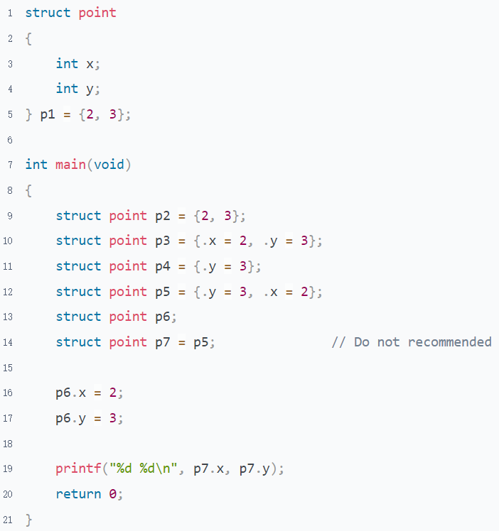

1. What is the problem using a struct as a function argument or return value?

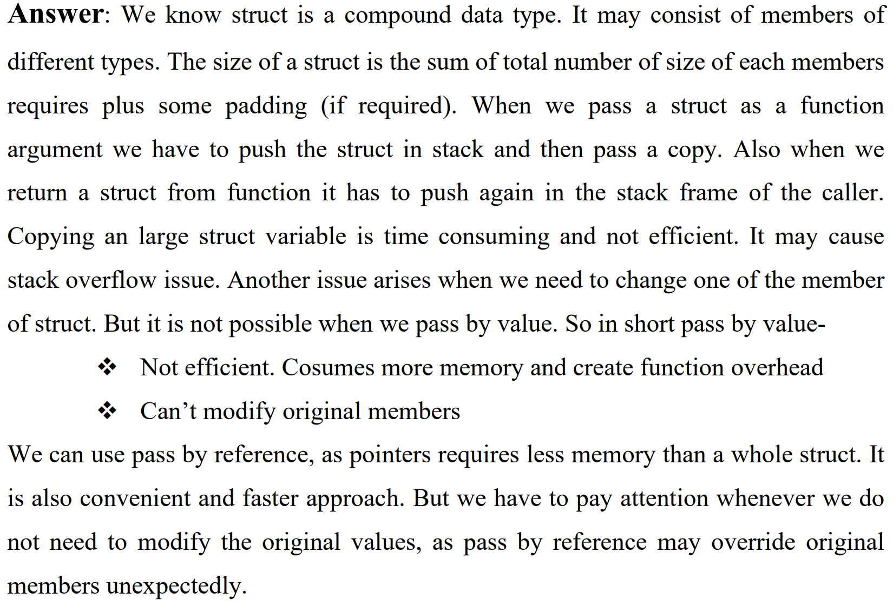

1. What is the difference between struct and union? Why do we need union?

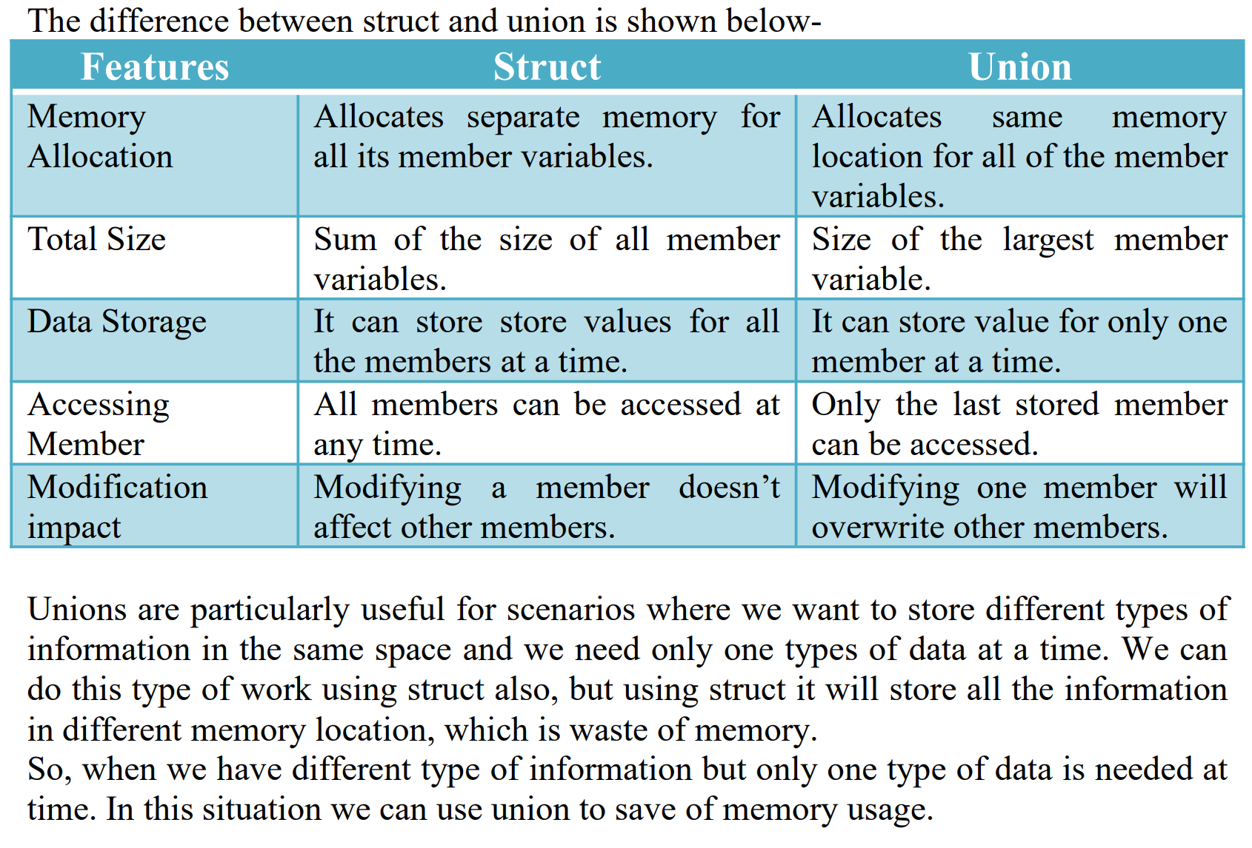

1. How to use bit fields in struct? Why do we need it?

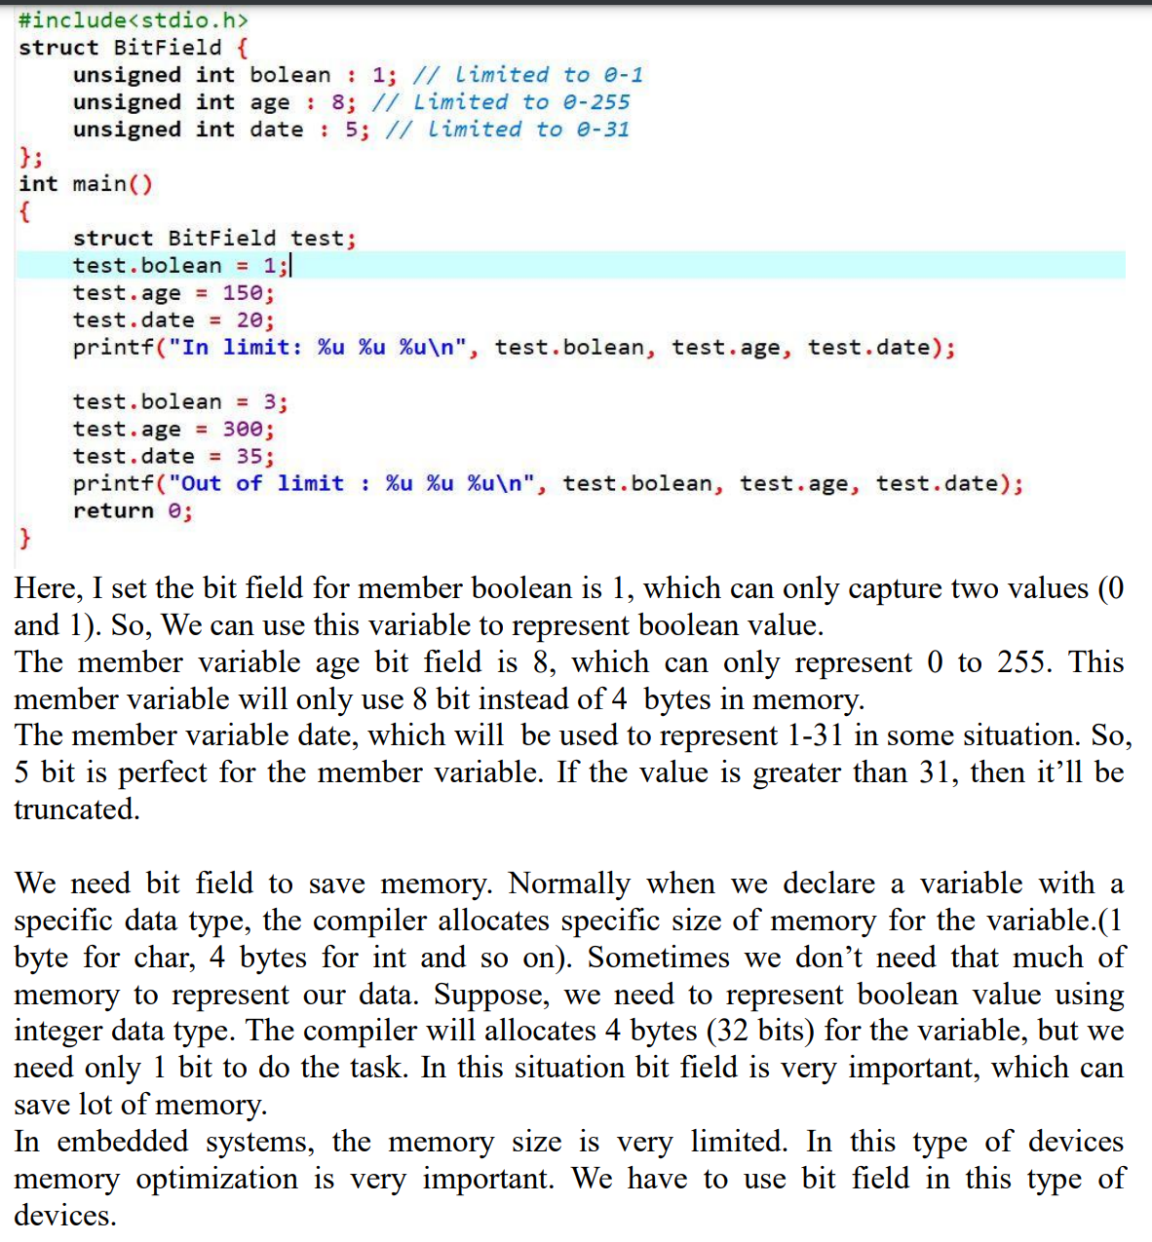

1. What is the output of the program on big endian and little-endian platform?

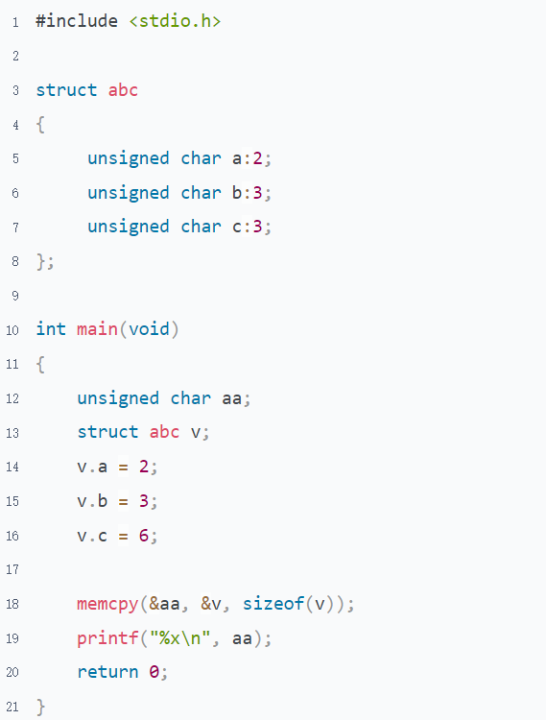

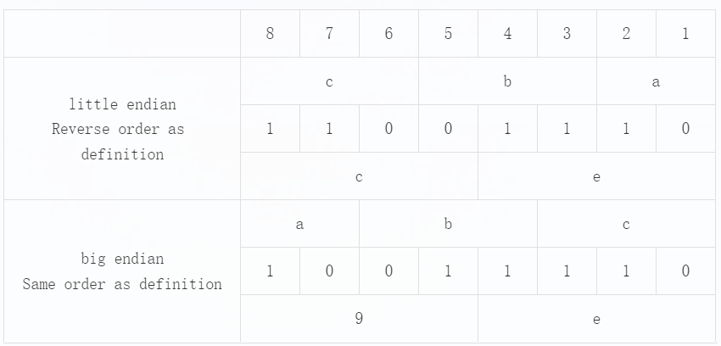

1. What's the output in the following program? Try to analyze

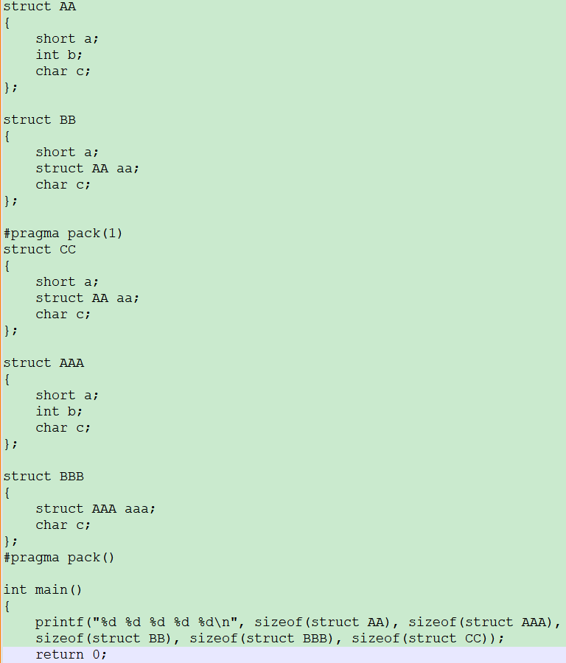

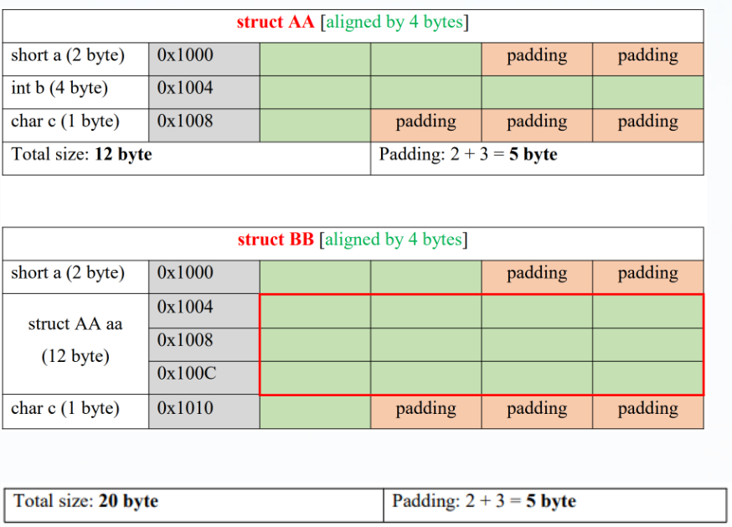

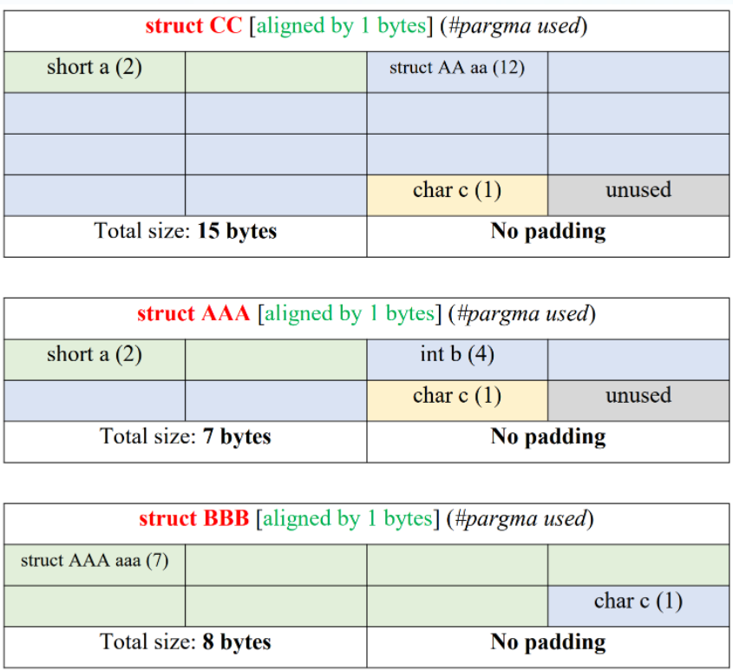

1. Based on the struct of the previous question, What are the outputs in the following program? Why?

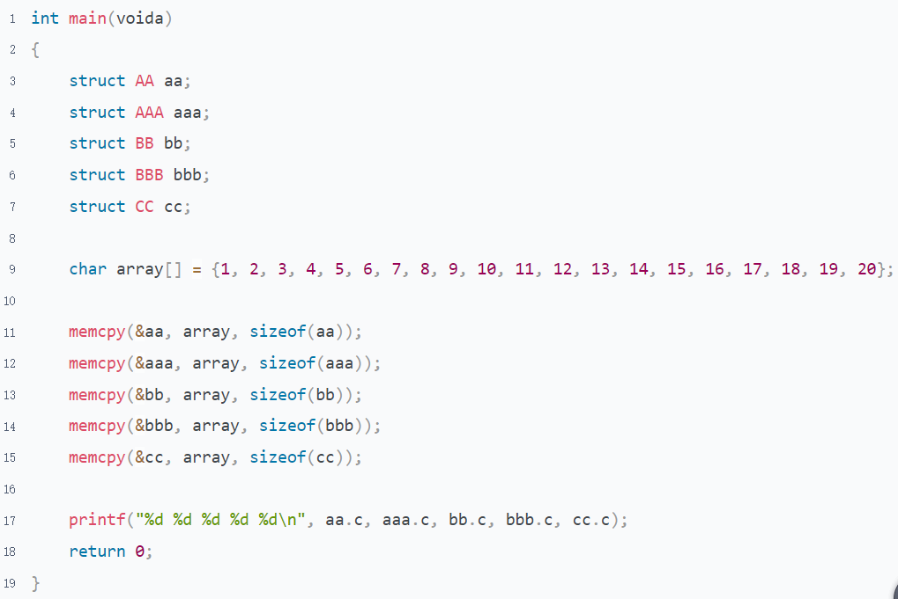

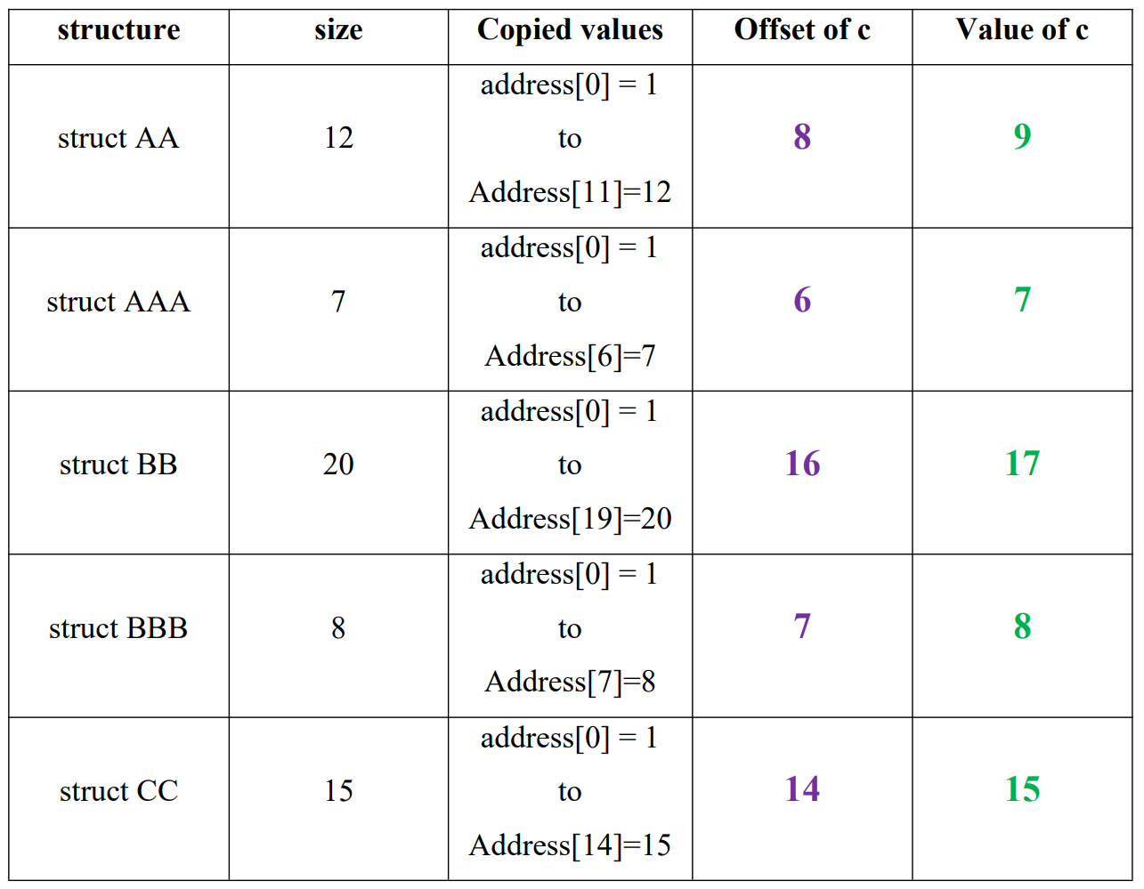

# Topic 5: Pointers

## Basic Knowledge

### Guidance

* Chapter: Pointers-On-C.pdf chapter 6.1-6.8
* Spend Time: 1 day
* Learn Suggestion: Learn from the assembly language
* Key Points
  + What's a pointer? Why is the C using it?
  + What's the difference between the different type of pointer?
  + What's a wild/dangling pointer?

### Practice

1. What can you learn from the following program? (From the perspective of variable content). Write the corresponding C code next to the assembly instruction

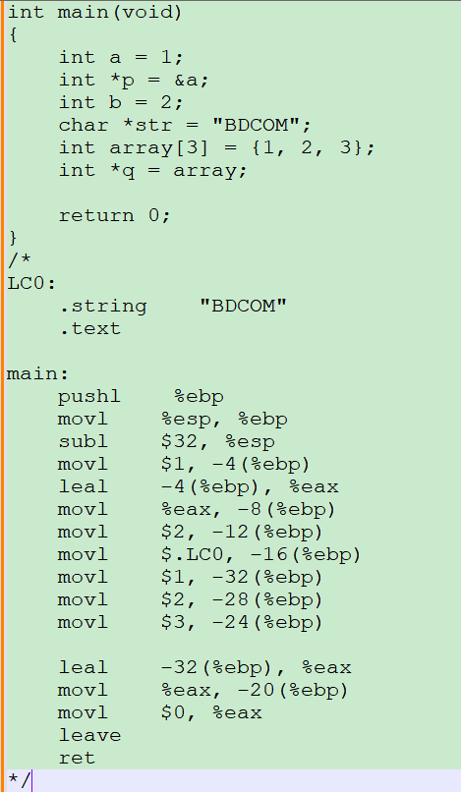

The content of normal variables is numbers that resemble an immediate value

The content of a pointer variable is the address of a normal variable or another address

An array is an ungapped space whose elements are pushed onto the stack one by one. The pointer only needs to hold the first address of the array if you want to manipulate the array through the pointer

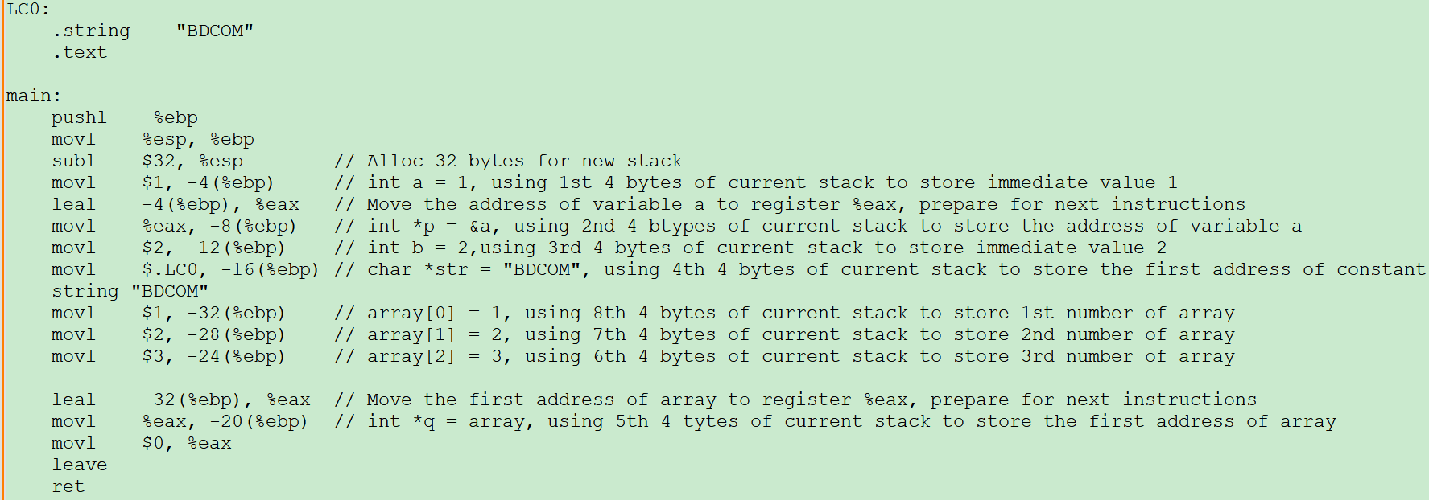

1. There is a program, p,*p and &p, Answer following questions

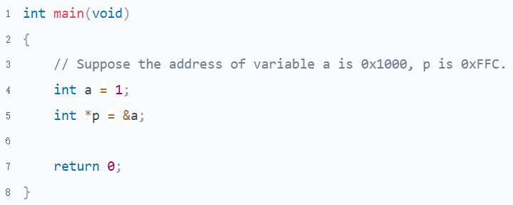

* 1. Short comparison between p, *p, &p?

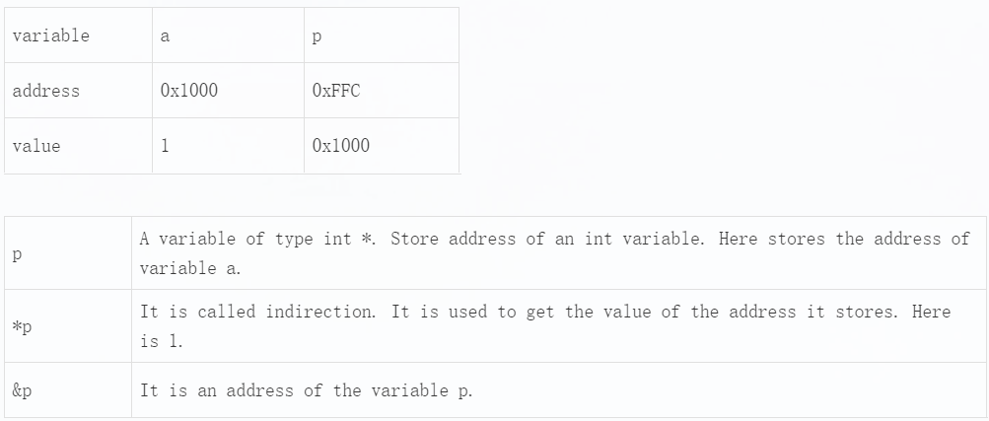

* 1. Which can be used as the l-value, and which can not in *p, p and &p?

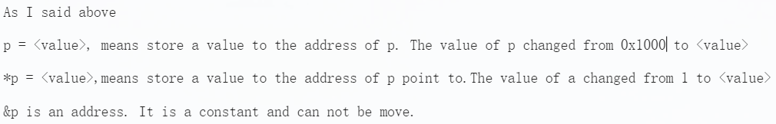

* 1. Fill the table, after each of the statements is executed

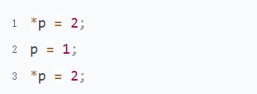

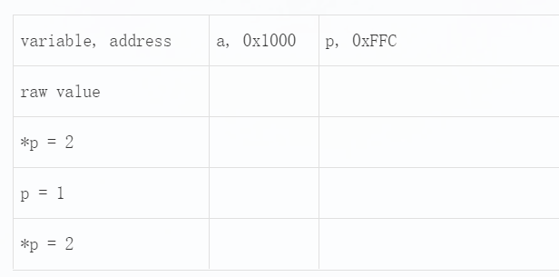

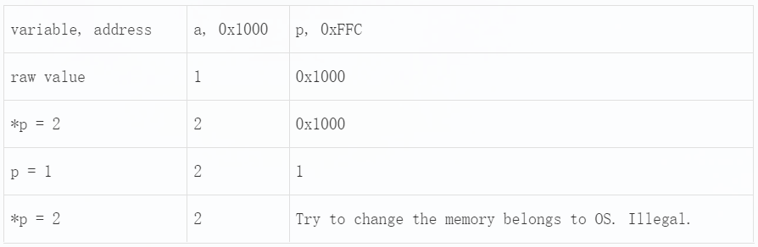

1. What can you learn from the following program? (From the perspective of pointer data type)

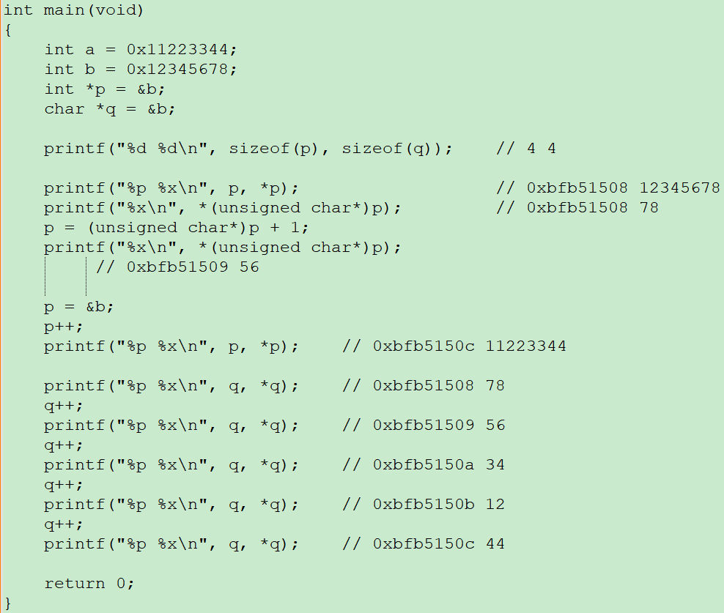

The step size of a pointer depends on its type.

The operation of a pointer is not limited by its type and can be converted to any type at any time if desired.

1. What is the wild pointer? Illustration

A wild pointer is a pointer that is not initialized before using.

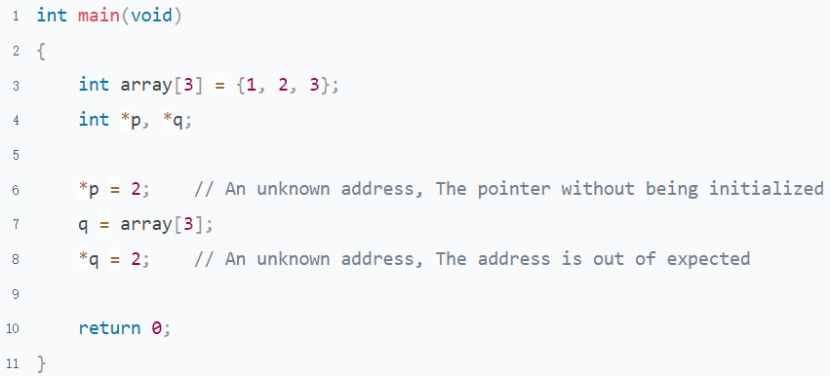

1. What is dangling pointer? Illustration

A dangling pointer is a pointer that has been released or no longer valid but is still in use.

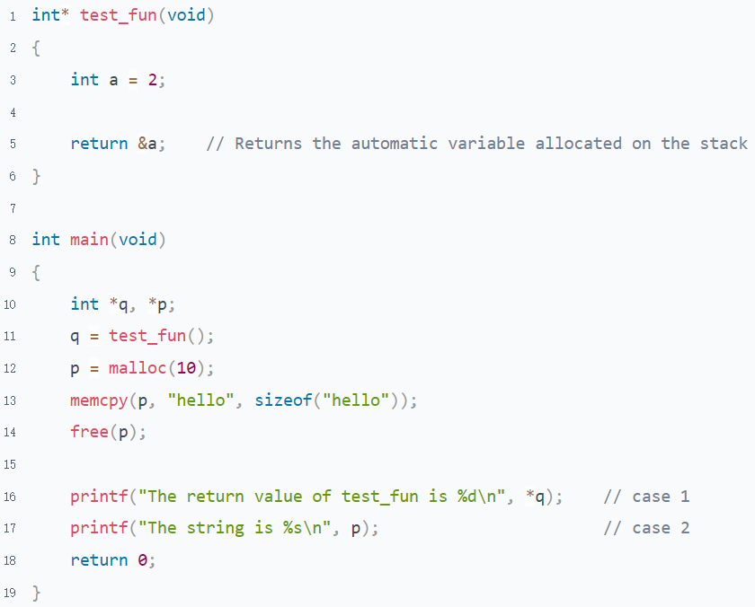

## Pointer & Array

### Guidance

* Chapter: Pointers-On-C.pdf 6.13.1 8.1; C-Primer-Plus.pdf 10
* Spend Time: 1.5 days
* Learn Suggestion: Learn pointer compare with array
* Key Points
  + What is the difference between array, &array[0] and &array
  + What happens when an array is the parameter of a function
  + What's the direct reference and indirect reference to an array?

### Practice

1. What can you learn from the following program?

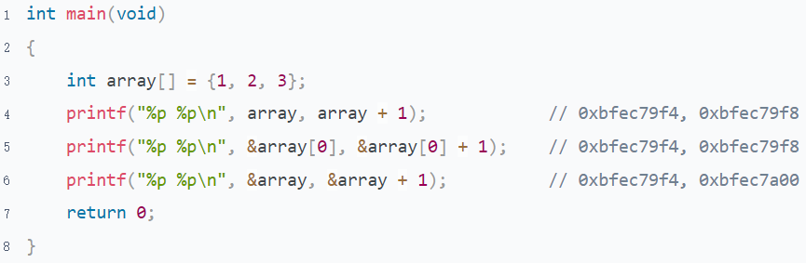

The array and &array[0] have the same meaning; they both represent the first element address of the array. Its type is "int *", which size is equivalent to the length of the address bus

&array is equivalent to int (*array)[3], which is a pointer to an array. Its step size is the whole array.

1. Why does the following program have such an output? Is it reasonable?

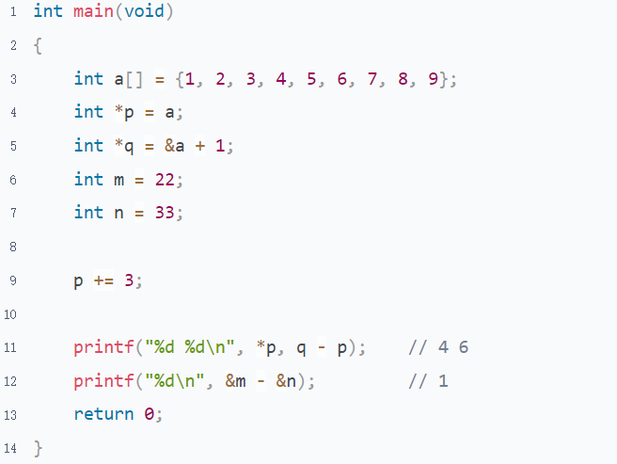

Pointer arithmetic should only occur within array ranges or between two pointers pointing to the same array. The operations outside the scope of the array are meaningless.

1. Why does the following program have such an output?

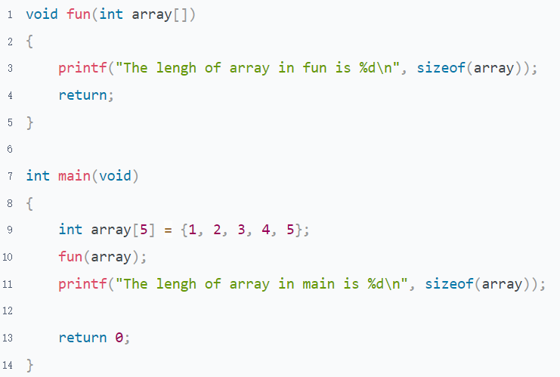

The array will auto convert to a pointer to the first element of the array when it as a r-value.

1. Why does the following program have such an output?

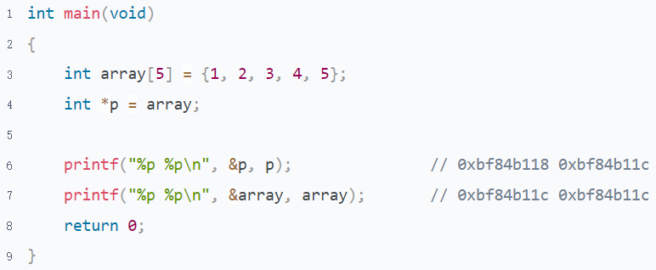

The output of &p and p are different, but the output of &array and array are the same.

There are 2 reasons for this

* The value or address of the pointer is in a different memory, but the array has only one space. So we use the array name to represent the first element address
* p and array have the same meaning, they both represent the address they store. Array is a sequential memory. Represented by the address of the first element(&array[0]).

1. Why can not an array be assigned just like a pointer?

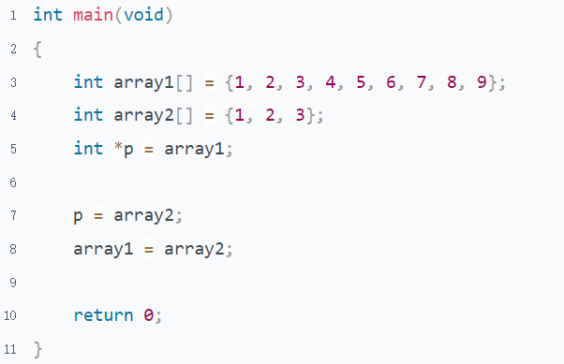

The array name cannot be used as a l-value, otherwise the array will be accessed improperly and cannot be released.

1. What is the difference between a, b and c？

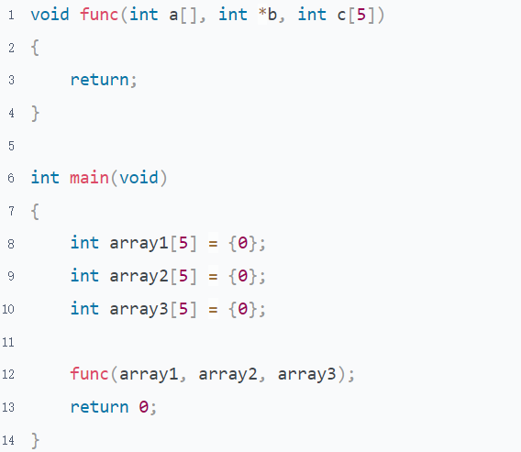

The formal parameters a, b, and c are all pointers to the compiler; The difference is that a[] and c[5] code are more readable and help the programmer understand the meaning of parameters more quickly.

1. Pointers-On-C.pdf 8.7 1

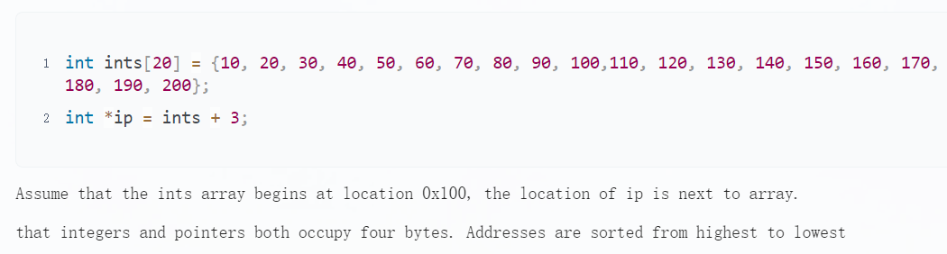

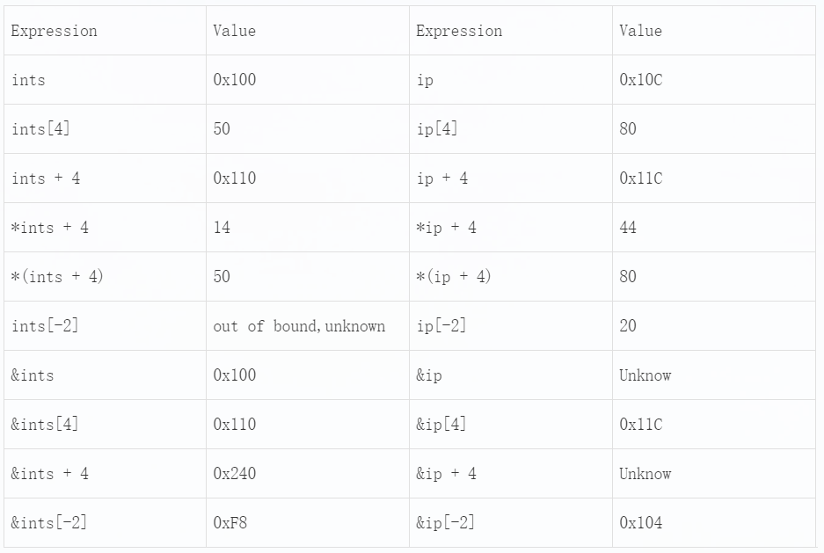

1. Here is a program, answer some questions

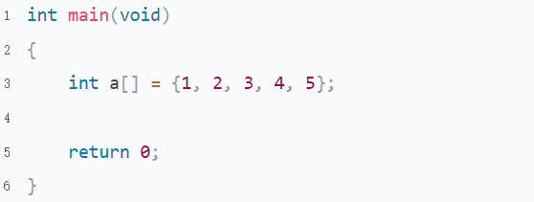

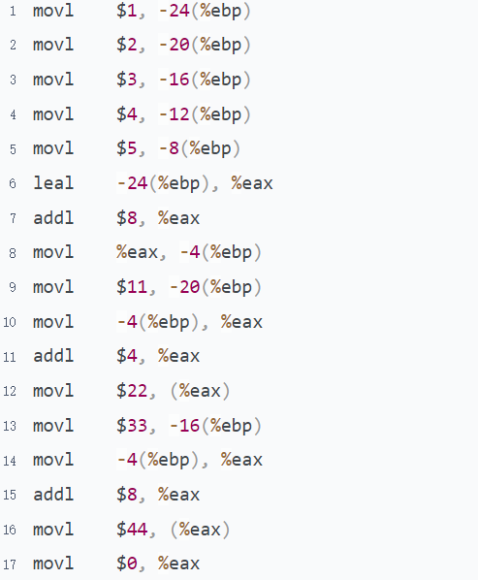

* 1. Convert the following assembly language to C language

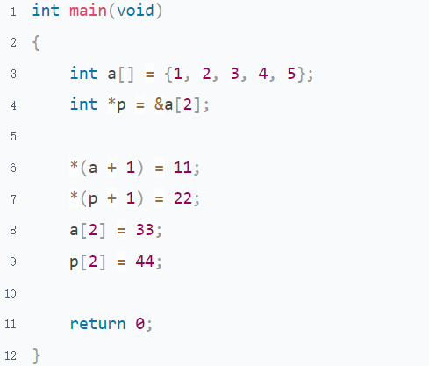

* 1. Which are the direct/indirect references in this program?

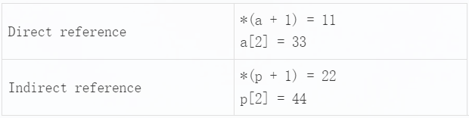

1. Convert the following assembly language to C language, What can you learn from the following program?

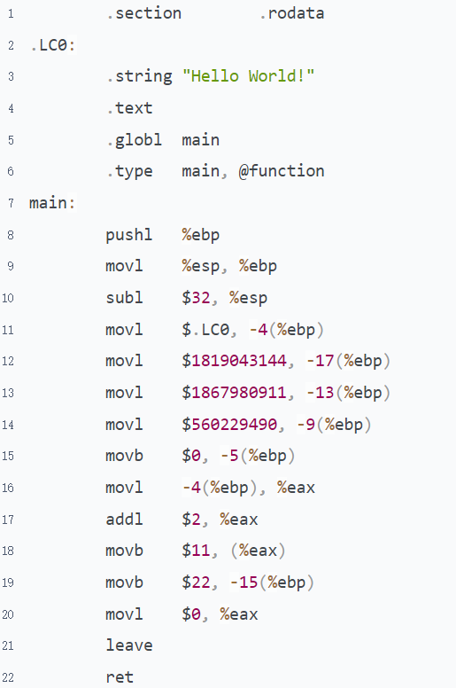

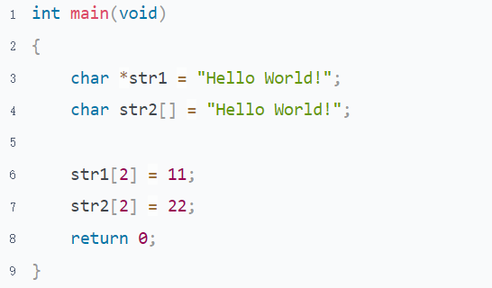

The way for string literals and character array data may be different, pushed into the stack.

## Pointer & Function

### Guidance

* Chapter: The-C-Programming-Language-2nd.pdf 5.2; Computer-Systems-A-Programmers-Perspective.pdf 3.4.2 3.5.1
* Spend Time: 1.5 days
* Learn Suggestion: Learn the behavior of passing a parameter by address to functions through assembly language
* Key Points
  + How the value of the parameter is changed when passing an address to the function?
  + How many approaches to get a new memory from another function?
  + What's the difference between mov[l|q] and lea[l|q] instruction?

### Practice

1. What can you learn from the following program?

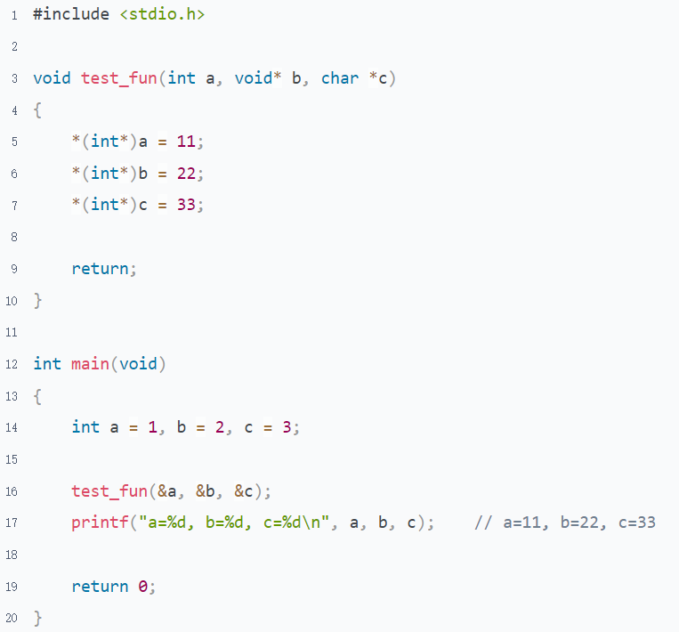

Pointer usage isn’t influenced by its type. Any pointer type can be converted to other types whenever necessary.

1. There is a program in file "Pointer and Function.c", Answer the following questions
   1. Write the corresponding C code next to the assembly statement

Refer to "Pointer and Function.c"

* 1. Draw some pictures to show the stack changes after each assembly instruction is executed

Refer to "Pointer and Function.xlsx"

1. What is the problem of the following program?

Rigorous inspections should be strengthened. such as, the process should be terminated when str is null.

* 1. P is a formal parameter whose address stores the value of str rather than its address. So the value of str is not changed.

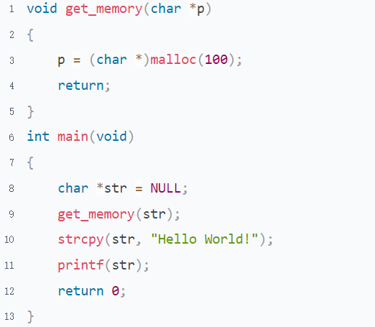

* 1. The address of p is allocated on the stack. It'll be invalid as the function get_memory exits.

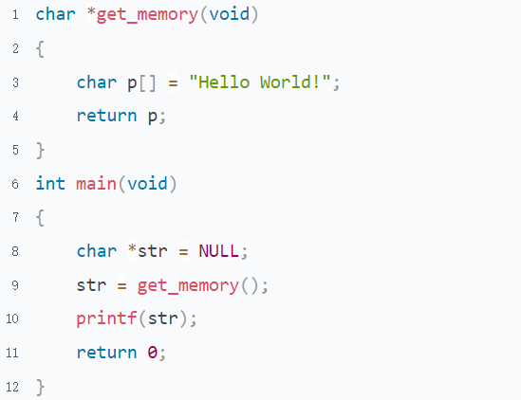

* 1. The Standard library functions malloc and free must be used in pairs

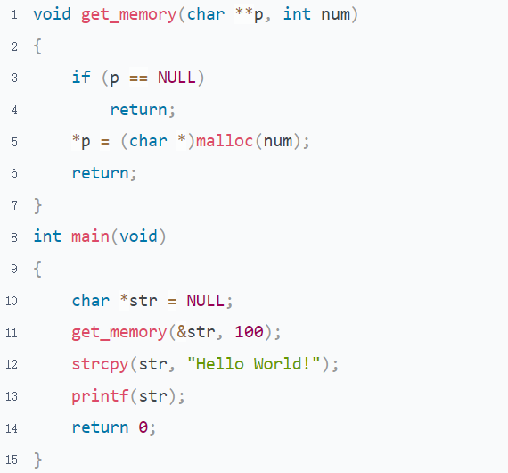

## Pointer & Struct

### Guidance

* Chapter: Pointers-On-C.pdf chapter 11 12
* Spend Time: 2 days
* Learn Suggestion: Structured the data
* Key Points
  + Why do we need the struct pointer? Why don't we use a struct variable directly? What are the benefits of a struct pointer?
  + How to maintain the new memory allocated by library functions malloc/calloc/realloc?
  + How to maintain a linked list? Append/Insert a new node to the linked list, Remove an existing node from the linked list.

### Practice

* Reference
  + RFC Document: Ethernet/IP(v4), DIX frame/rfc791
  + Technic Point: Linked list, Data structuring, Data Alignment in the packet, Bit field in the struct
* Description
  + Capture at least 10 complete IP packets by Wireshark and store them to a file.
  + Read the packet from the file individually and build a linked list to store them.
  + Create a new node for the packet if it's nonexistent (same src/dest ip) in the structure, otherwise auto-increment 1 to the reference counter. print out the reminder information
  + Print out the key-information(smac/dmac/sip/dip) of a packet when handle it
* Requirements
  + The raw data need to be structured
  + Portability needs to be considered

# Topic 6: Advanced Pointers

## Pointer to Pointer & Array of Pointer

### Guidance

* Chapter: Pointers-On-C.pdf chapter 6.10 8.3 13.1 13.4
* Spend Time: 1 day
* Learn Suggestion: Understanding the memory address and the relationship of each type of variable
* Key Points
  + Why do we need a pointer to pointer?
  + What is an array of pointer? Why do we need it?
  + What is the difference between an array of pointer and a normal array?
  + What is the relationship between an array of pointer and a pointer to pointer?

### Practice

1. Here is a program, and answer some questions

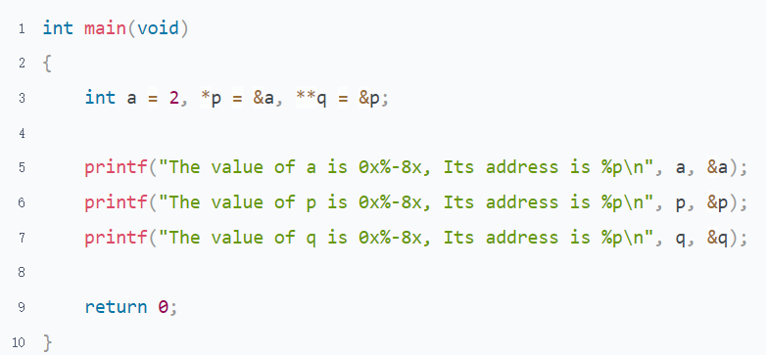

* 1. Draw a picture to show the relationship between these 3 variables
  2. What does the following expression mean?

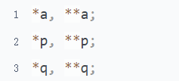

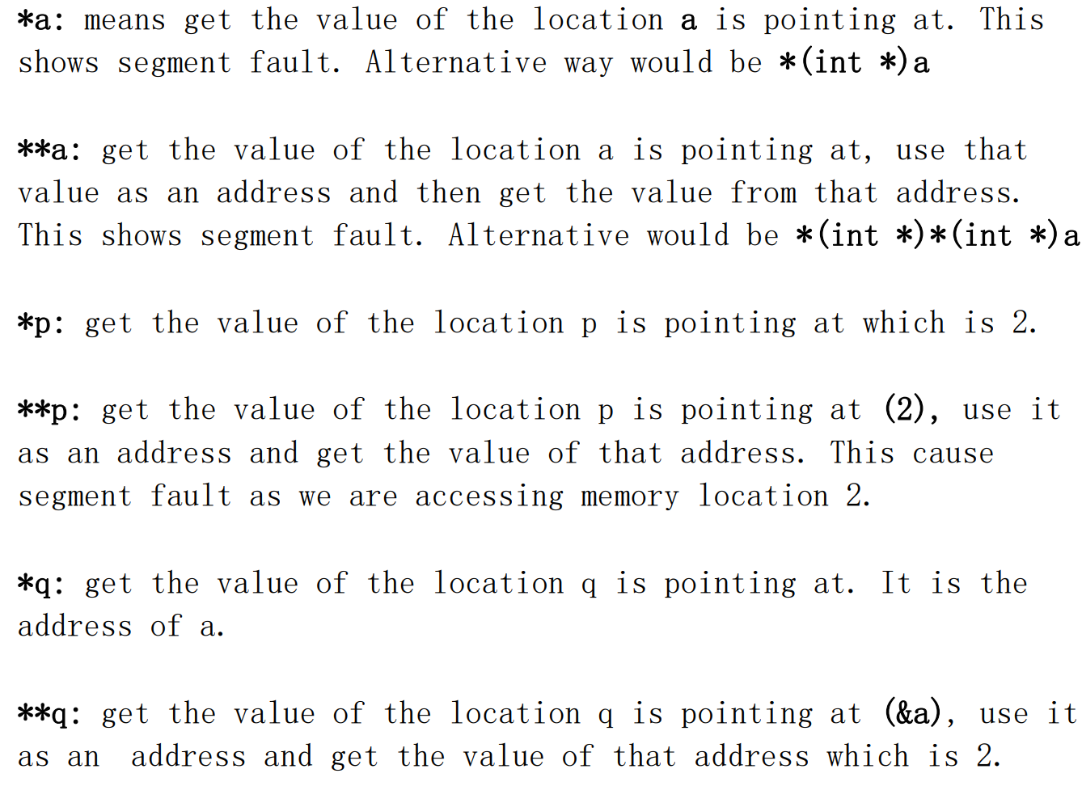

* 1. Based on the main program. What can you learn from the following program?

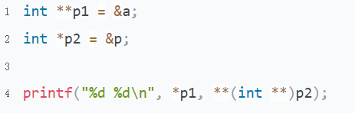

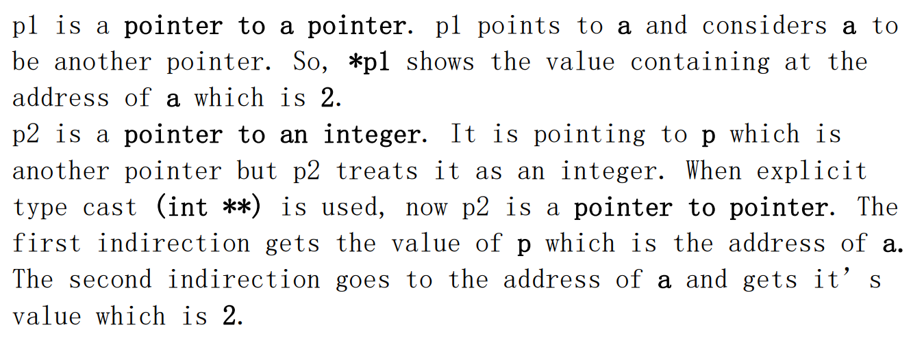

1. Read the program below, and answer some questions

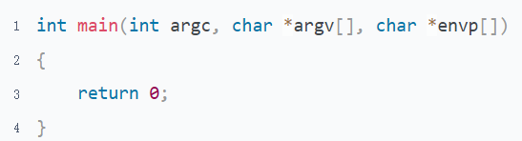

* 1. What kind of data is stored in argv and envp? Where are they stored in memory?

argv and envp are both array of pointer. They store different kinds of strings. Get from parent process.

They are stored between the stack and the kernel memory.

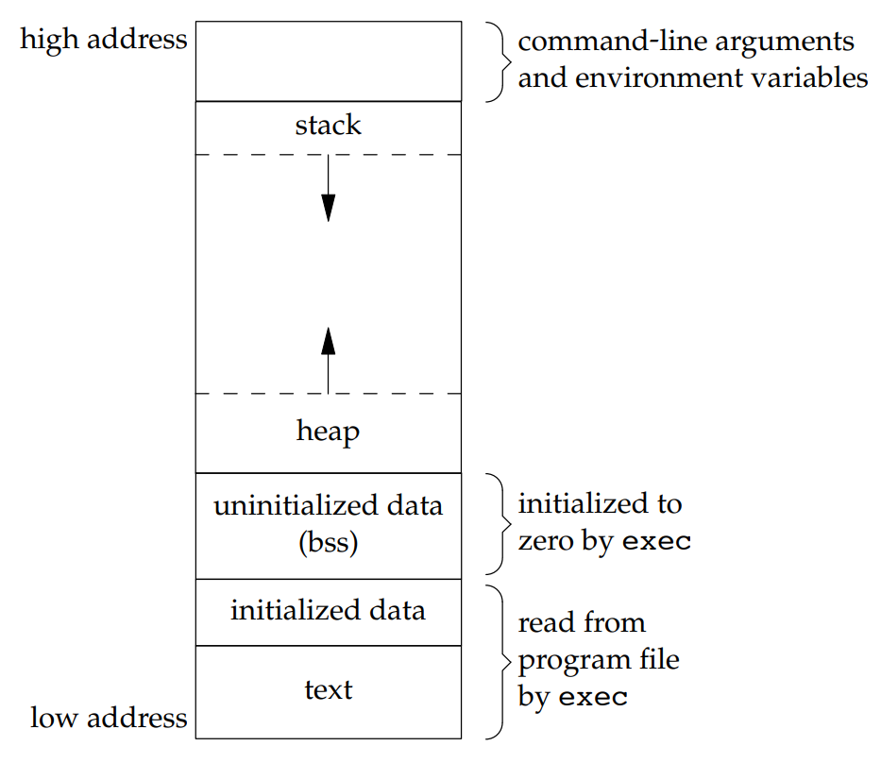

* 1. How many ways to get the content of argv?

We can get the content of the argv using 2 ways

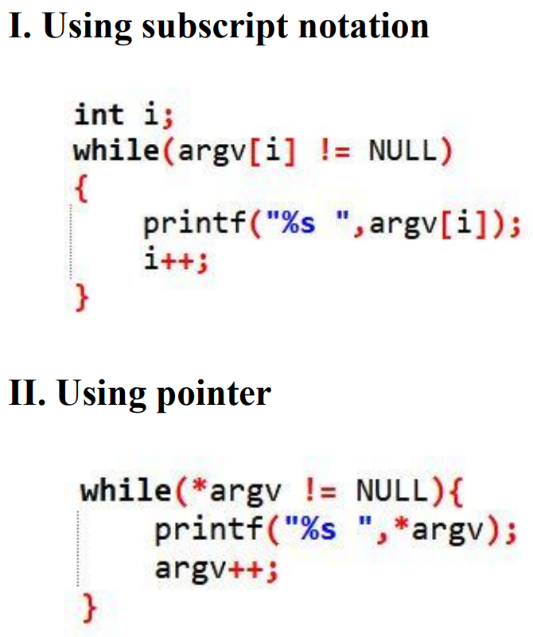

* 1. What is the difference between char *argv[] and char **argv in here?

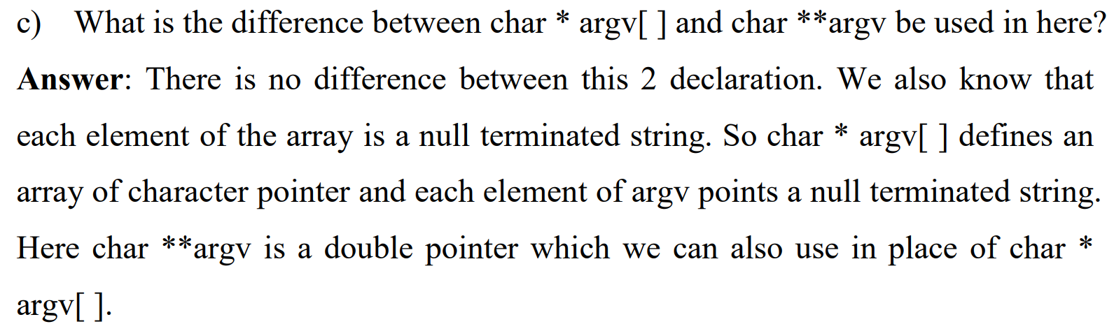

1. In which scenario is a pointer to pointer used?

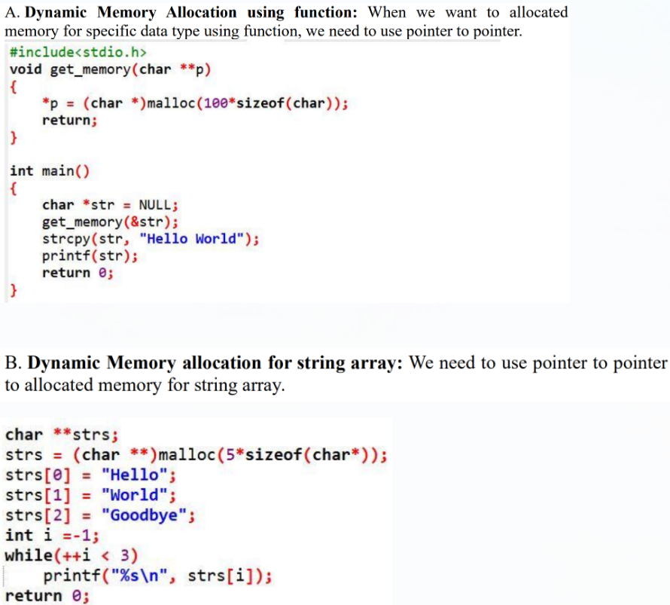

1. What is the relationship between an array of pointer and a pointer to pointer?

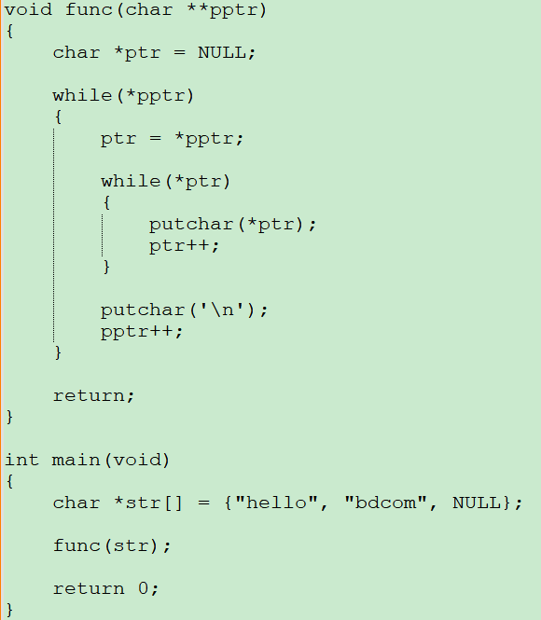

There are two associations

* We can indirectly access each element of an array of pointer by a pointer to pointer
* They are the same in some situations, ex. As a formal parameter of a function

## Pointer to Array & Multi-Dimensional Array

### Guidance

* Chapter: Pointers-On-C.pdf 8.2; Understanding-And-Using-C-Pointers.pdf chapter 4
* Spend Time: 1 day
* Learn Suggestion: Row-major and step size
* Key Points
  + What's the meaning of the different forms of MD array?
  + What is the relationship between MD array and pointer to array?
  + In what scenario can a pointer to array be used?

### Practice

1. There is a 2D array, answer some questions



* 1. What's the meaning of &array_2d、array_2d，&array_2d[0]，array_2d[0]，&array_2d[0][0]?
  2. What is the relationship between a 2D array and a pointer to array?
  3. How to access each element of the two-dimensional array through a pointer to array?

1. Why do we need a pointer to array? What is it used for?
2. Pointers-On-C.pdf 8.7 11
3. Pointers-On-C.pdf 8.7 13

## Pointer to Function

### Guidance

* Chapter: Understanding-And-Using-C Pointers.pdf chapter 3; Pointers-On-C.pdf 13.3
* Spend Time: 1 day
* Learn Suggestion: Passing a function just like a value between the different functions
* Key Points
  + Why do we need this technique? What can it bring to us?
  + How to use this technique to implement the idea of object orientation?
  + How to use this technique to implement enhanced code portability?

### Practice

1. Implement the following program by pointer to function

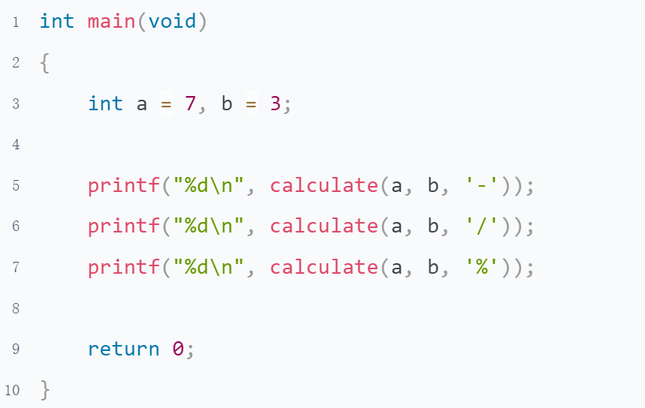

1. Implement the Jump Tables on page 360 of the book Pointers-On-C.pdf
2. The main function and output have already been provided, to complete the remaining parts.

